**Navrachana University**

**CMP402 (Software Testing Basics)  
Lab File: 4**

**Introduction To Selenium Web Driver**

**Q. Perform web testing of “https://**[**www.saucedemo.com/**](http://www.saucedemo.com/)**”.**

**USER 1 – TEST CASES**

**Input:**

static SafariDriver driver = new SafariDriver();

driver.get("https://www.saucedemo.com/");

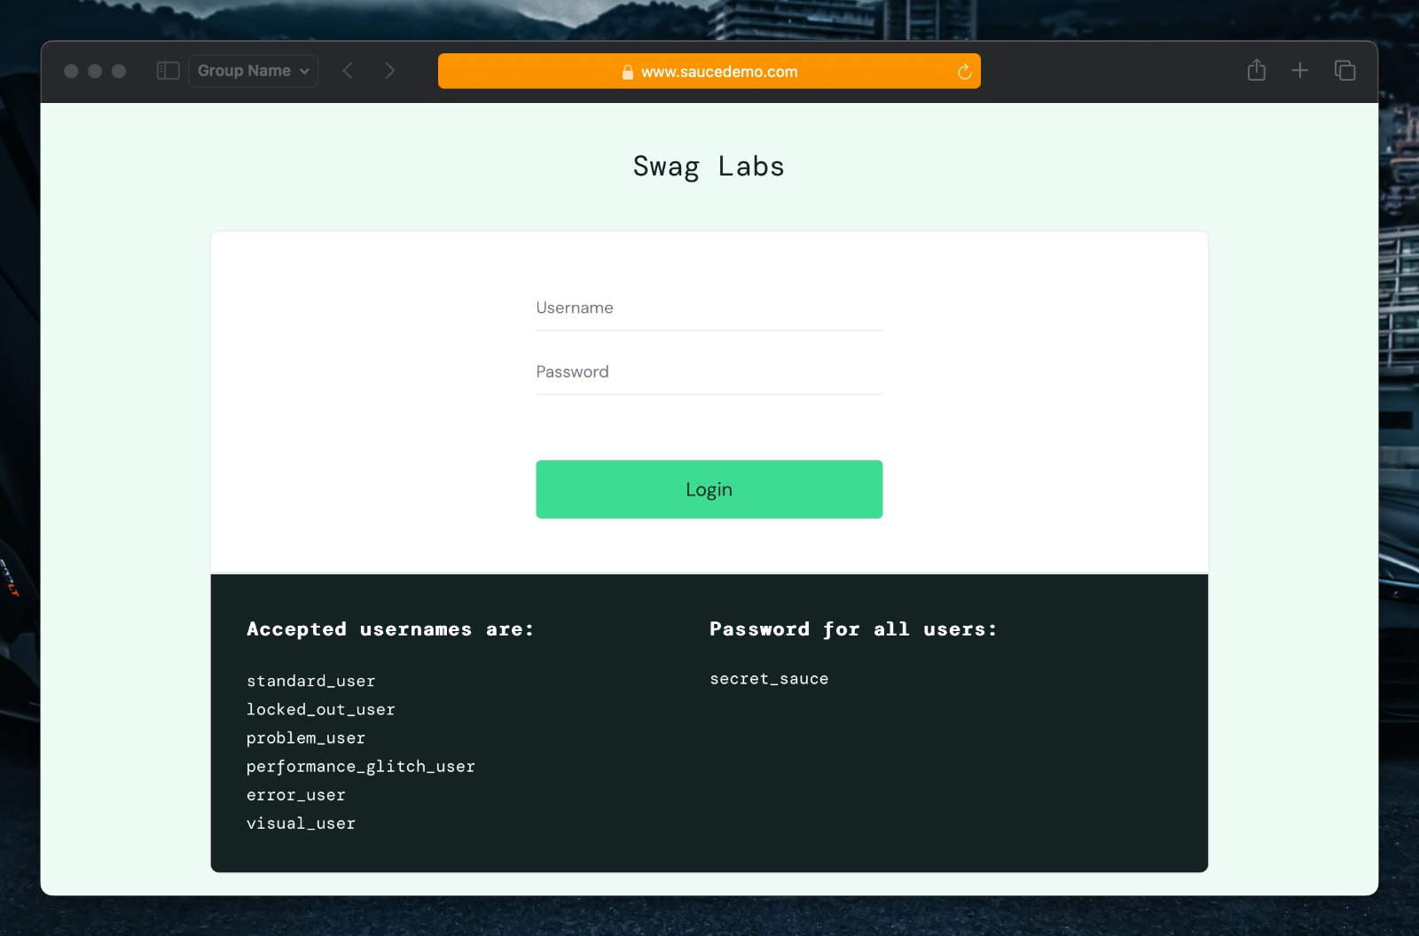**Output:**

**Input:**

loginUser("standard_user");

static void loginUser(String username) {

        clear();

        driver.findElement(By.id("user-name")).sendKeys(username);

        driver.findElement(By.id("password")).sendKeys("secret_sauce");

        delay(1);

        driver.findElement(By.id("login-button")).click();

        delay(2);

}

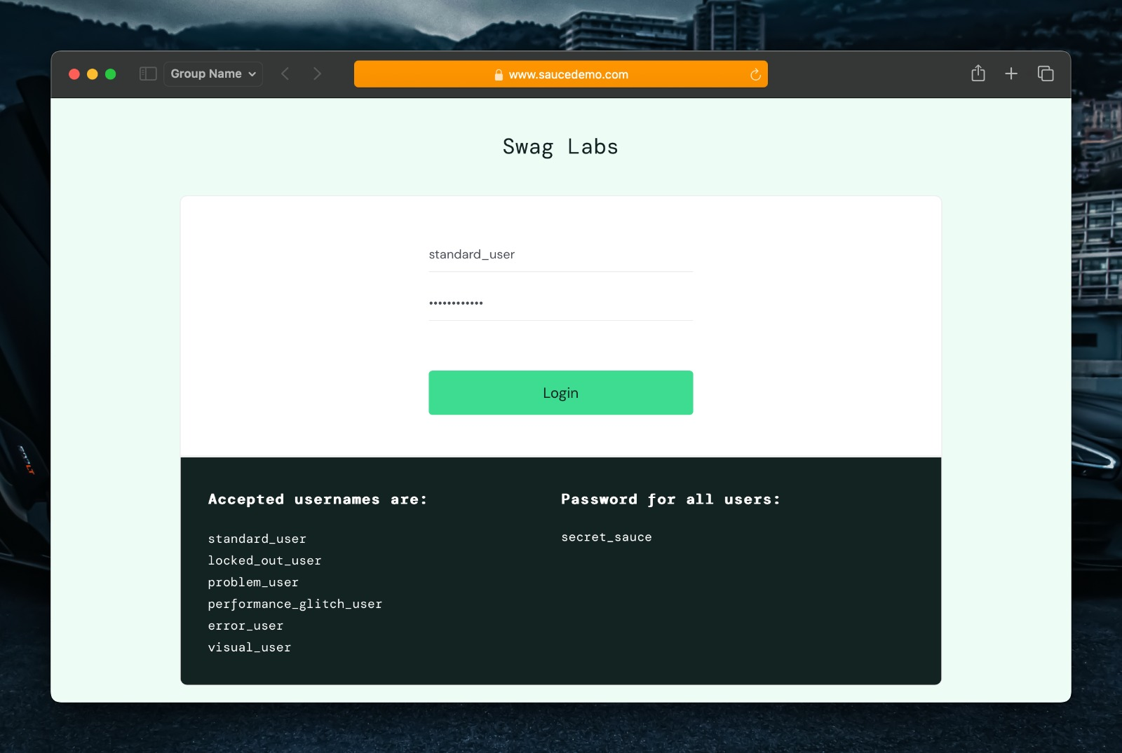**Output:**

**Input:**

*//Product Sort and Filter*

productSortAndFilter();

static void productSortAndFilter() {

        delay(2);

*//trying to click the sort button using various classnames*

        try {

            driver.findElement(By.className("product_sort_container")).click();

        } catch (Exception e) {

            try {

                driver.findElement(By.className("select_container")).click();

                driver.findElement(By.xpath("//*[@id=\"header_container\"]/div[2]/div/span/select")).click();

            } catch (Exception ex) {

                System.out.println("Unable to find the element");

} }

*//sort products by Name (Z to A)*

        driver.findElement(By.xpath("//*[@id=\"header_container\"]/div[2]/div/span/select/option[2]")).click();

        delay(1);

*//sort products by price (low to high)*

        driver.findElement(By.xpath("//*[@id=\"header_container\"]/div[2]/div/span/select/option[3]")).click();

        delay(1);

*//sort products by price (high to low)*

        driver.findElement(By.xpath("//*[@id=\"header_container\"]/div[2]/div/span/select/option[4]")).click();

        delay(1);

}

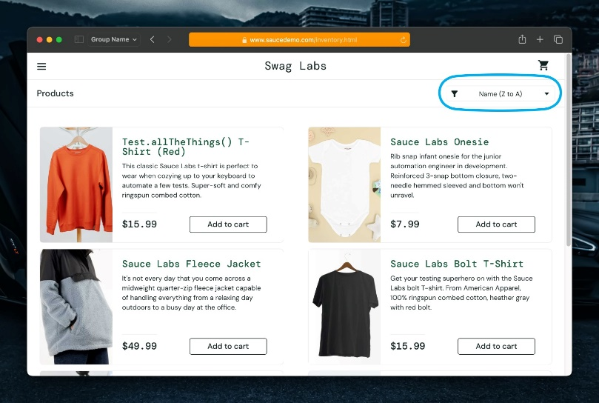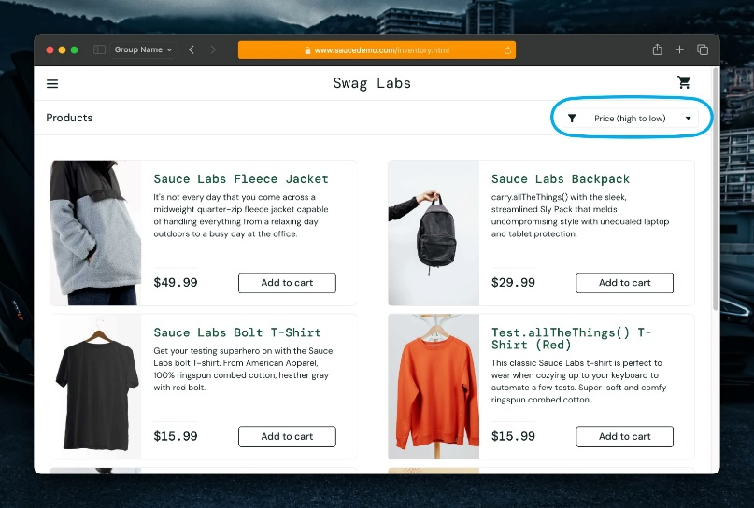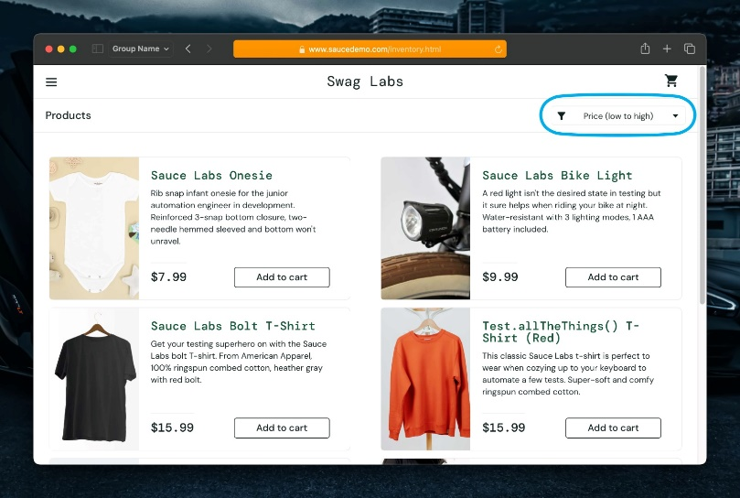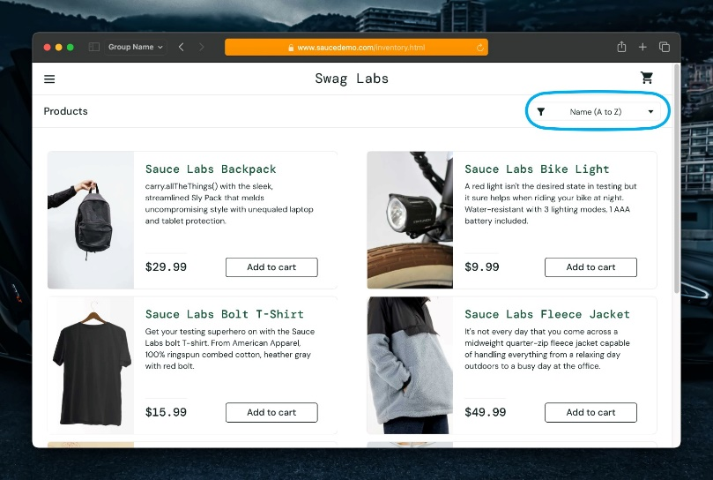**Output:**

**Input:**

*// Product Add to Cart*

    static void addToCart() {

*//add and remove "Sauce Labs Backpack" to cart*

        driver.findElement(By.id("add-to-cart-sauce-labs-backpack")).click();

        delay(1);

        driver.findElement(By.id("remove-sauce-labs-backpack")).click();

        delay(1);

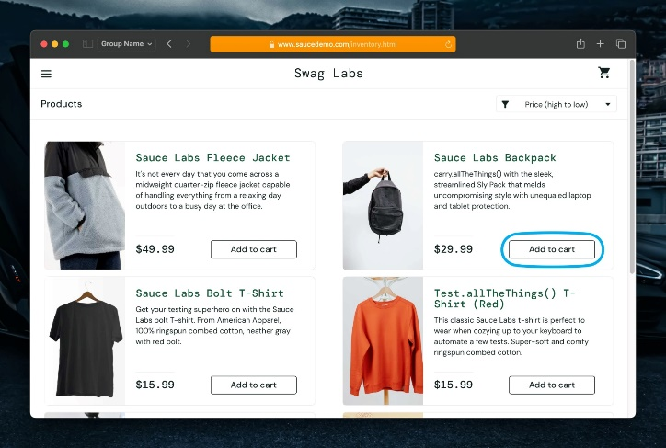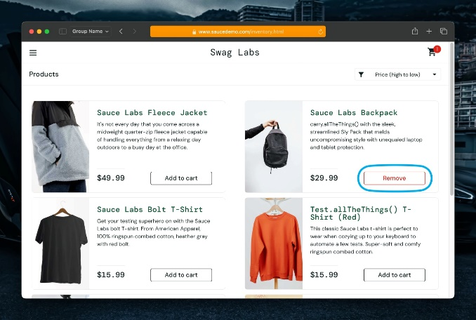**Output**:

**Input:**

*//add products to cart*

        driver.findElement(By.id("add-to-cart-sauce-labs-bike-light")).click();

        delay(1);

        driver.findElement(By.id("add-to-cart-sauce-labs-onesie")).click();

        delay(1);

        driver.findElement(By.id("add-to-cart-sauce-labs-bolt-t-shirt")).click();

        delay(1);

        driver.findElement(By.id("add-to-cart-test.allthethings()-t-shirt-(red)")).click();

        delay(1);

        driver.findElement(By.id("add-to-cart-sauce-labs-fleece-jacket")).click();

    }

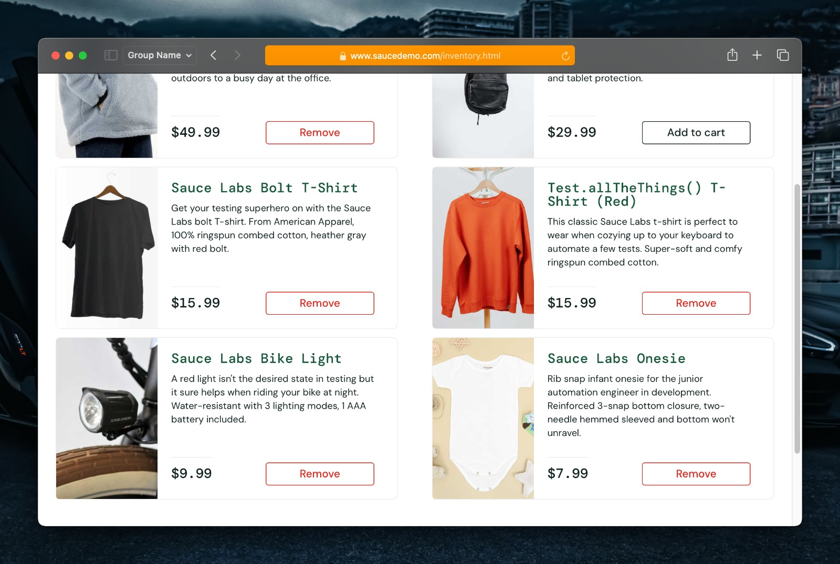**Output:**

**Input:**

*// Cart Functions*

cartFunctions()

    static void cartFunctions() {

*//navigate to cart*

        driver.findElement(By.id("shopping_cart_container")).click();

        delay(1);

*//remove "Sauce Labs Onesie" from cart*

        driver.findElement(By.id("remove-sauce-labs-onesie")).click();

*//checkout*

        driver.findElement(By.id("checkout")).click();

    }

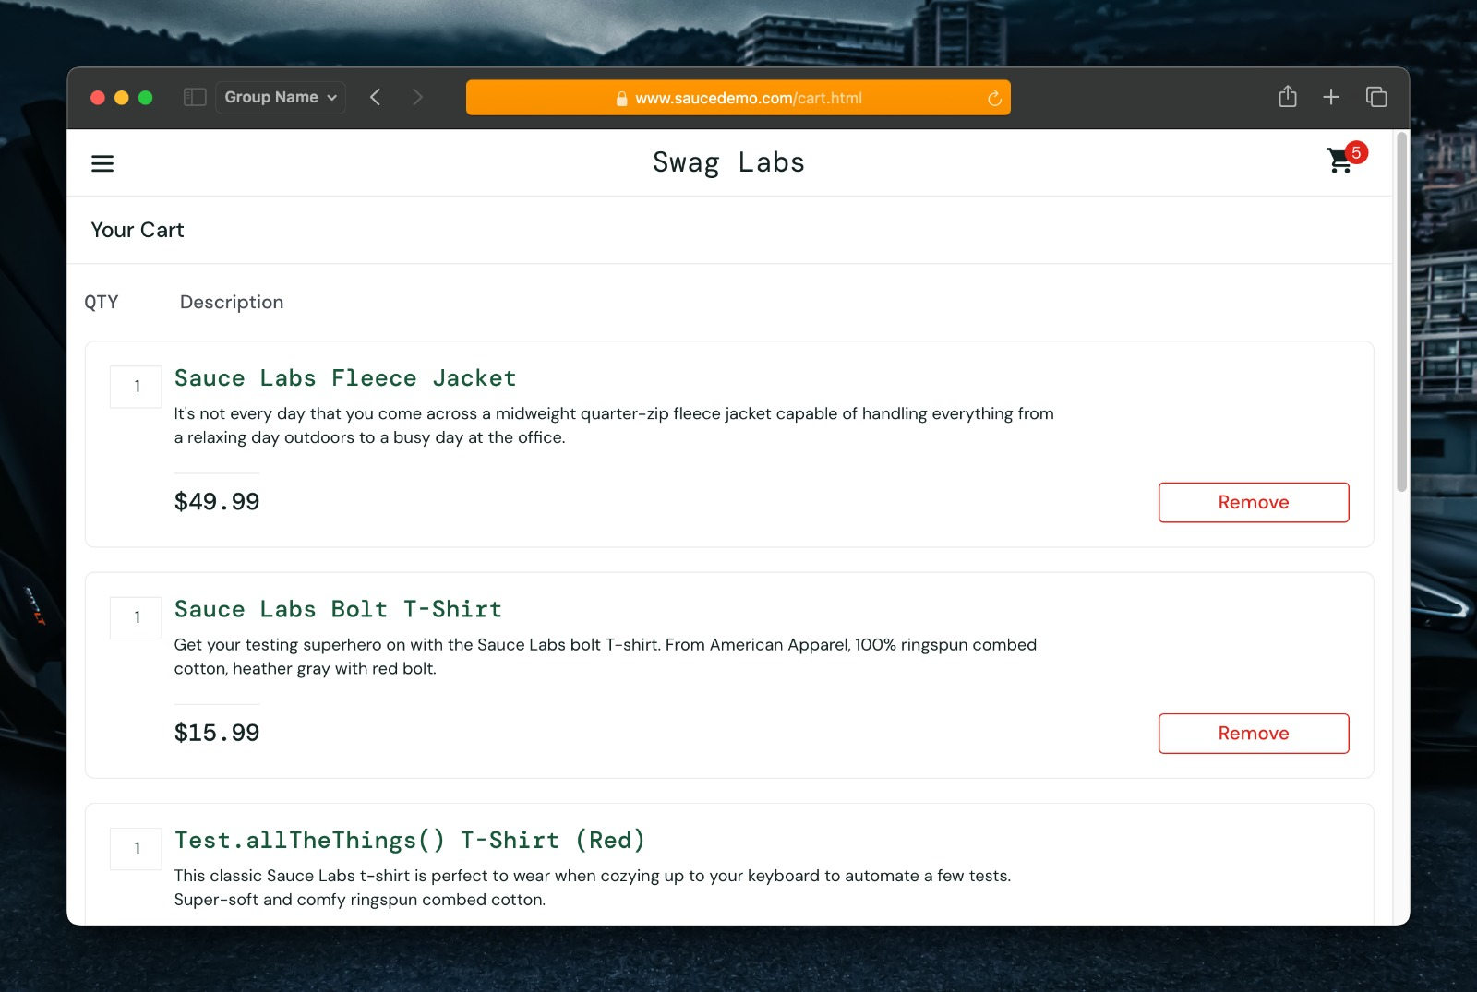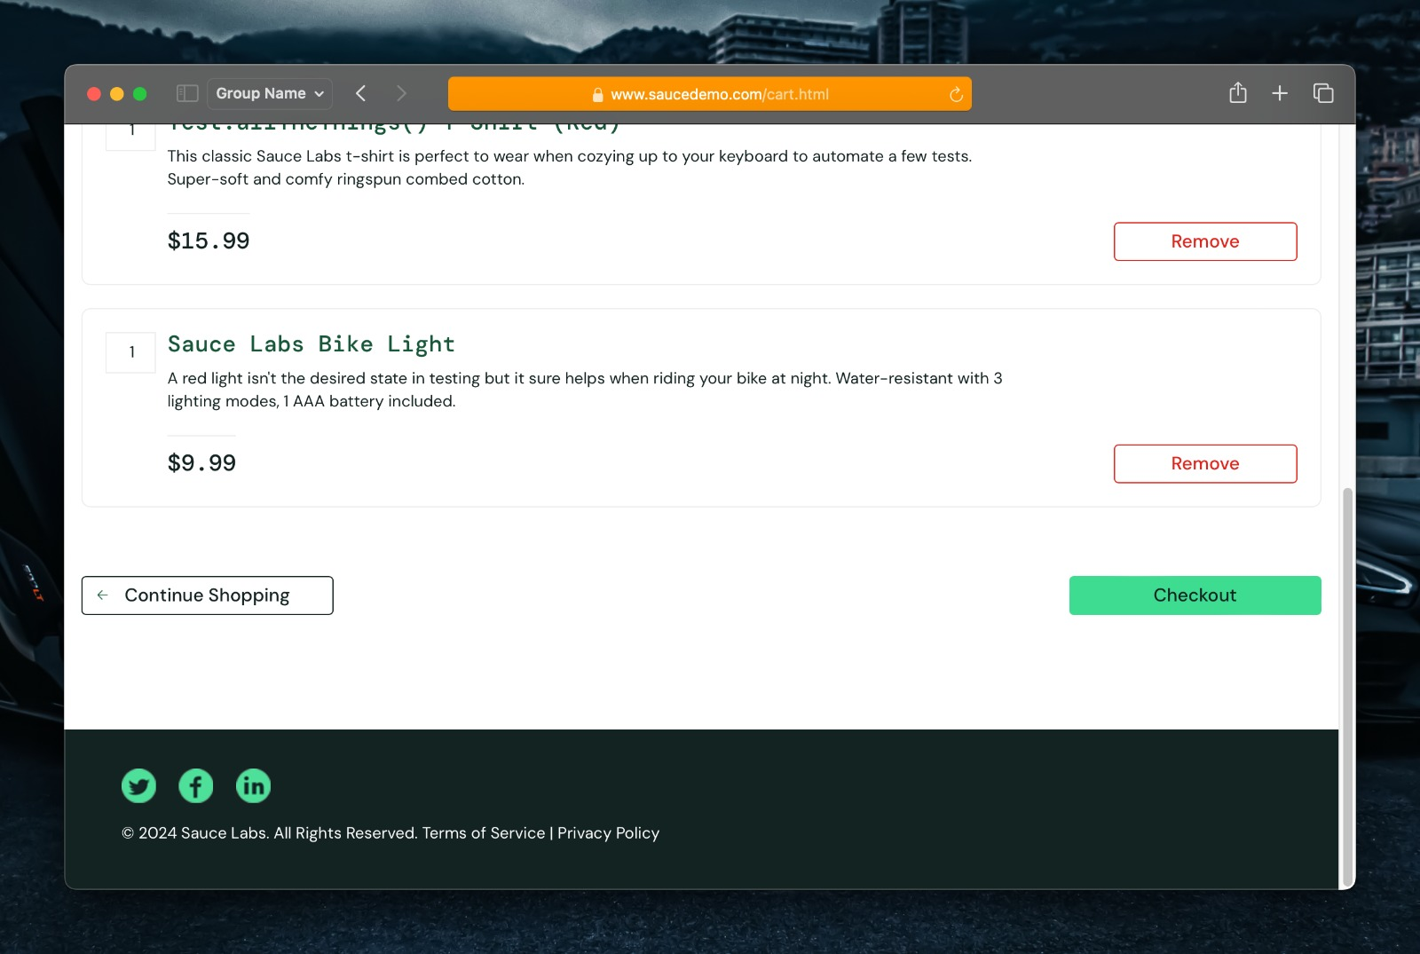**Output:**

**Input:**

*// Checkout Functions*

    checkoutFunctions()

static void checkoutFunctions() {

*//fill out checkout information*

        try {

            driver.findElement(By.id("first-name")).sendKeys("Abhie");

            driver.findElement(By.id("last-name")).sendKeys("Mon2");

            driver.findElement(By.id("postal-code")).sendKeys("390002");

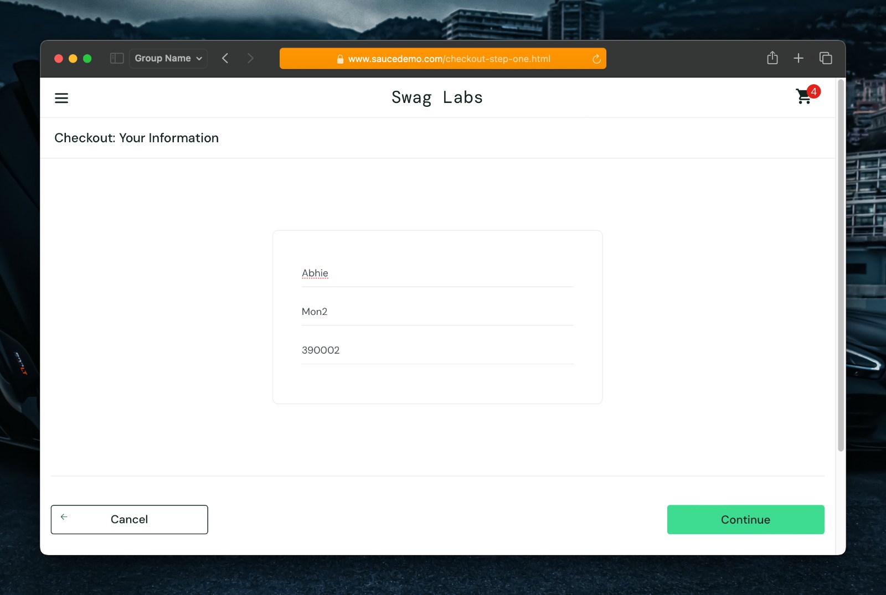**Output:**

**Input:**

*//continue to overview*

            driver.findElement(By.id("continue")).click();

*//finish checkout*

            delay(1);

            driver.findElement(By.id("finish")).click();

            delay(1);

*//back to products*

            driver.findElement(By.id("back-to-products")).click();

*//if last name couldn't be entered, cancel checkout*

        } catch (Exception e) {

            driver.findElement(By.id("cancel")).click();

        }

}

**Output:**

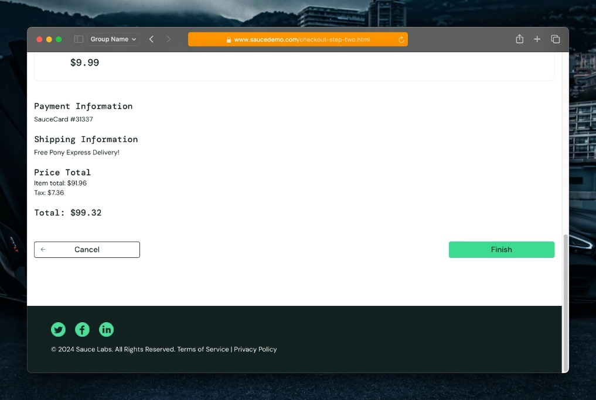

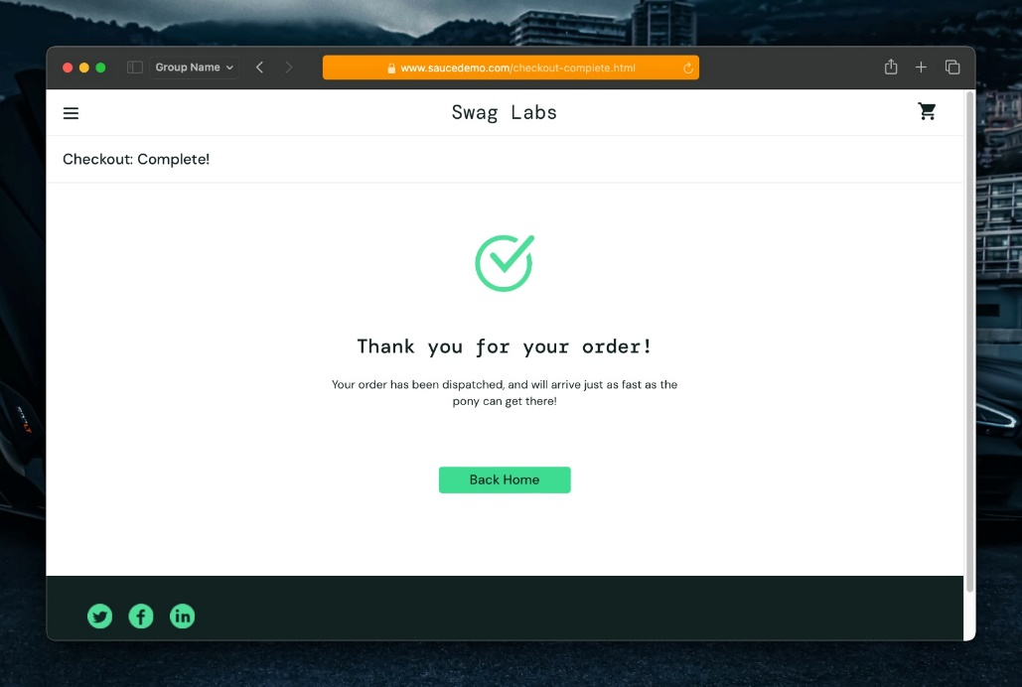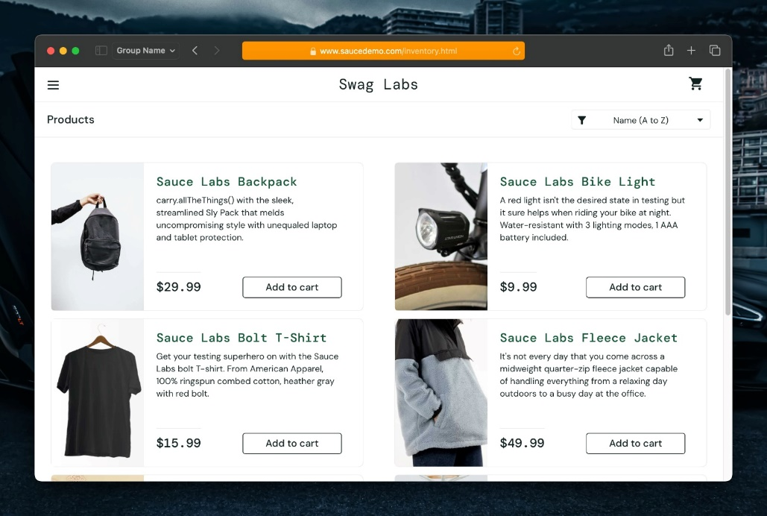

**Input:**

links()

static void links() {

*//navigate to social media links*

         driver.findElement(By.xpath("//*[@id=\"page_wrapper\"]/footer/ul/li[1]/a")).click(); *//twitter*

         driver.findElement(By.xpath("//*[@id=\"page_wrapper\"]/footer/ul/li[2]/a")).click(); *//facebook*

         driver.findElement(By.xpath("//*[@id=\"page_wrapper\"]/footer/ul/li[3]/a")).click(); *//linkedin*

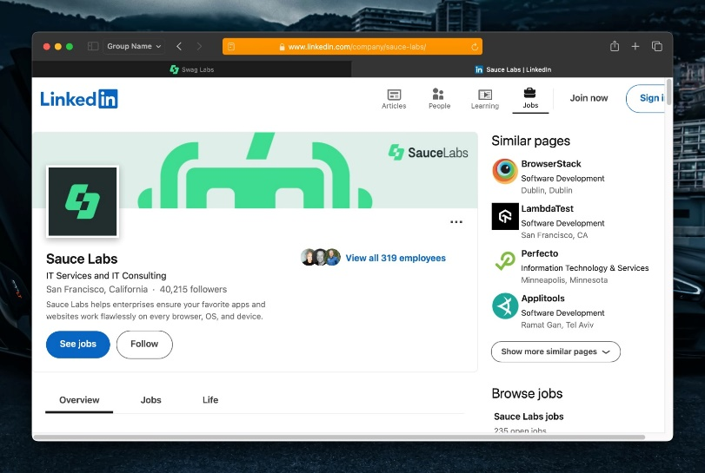**Output:**

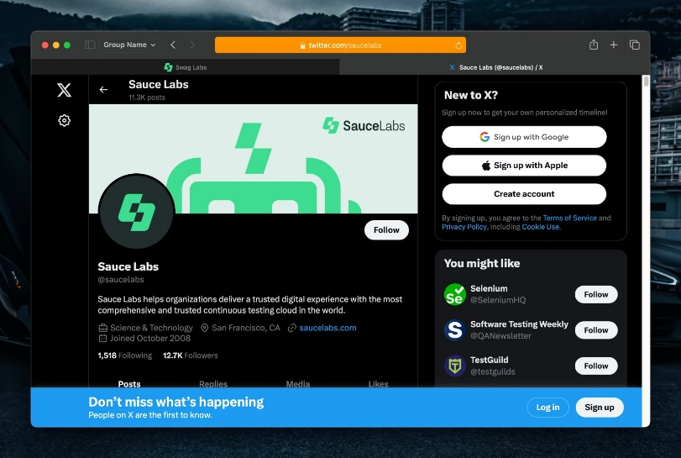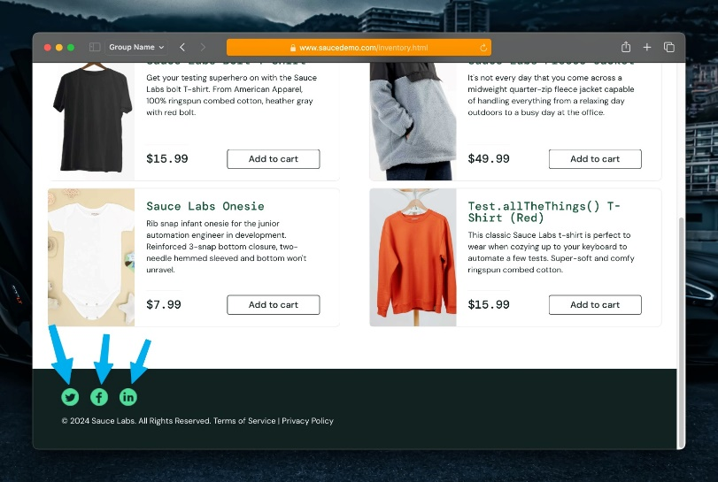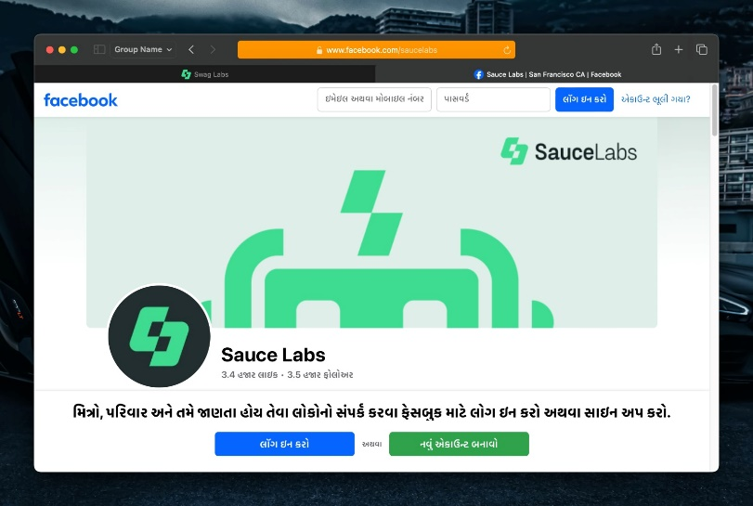**Input:**

*//click on the burger menu*

        driver.findElement(By.id("react-burger-menu-btn")).click();

        delay(1);

*//about us*

        driver.findElement(By.id("about_sidebar_link")).click();

}

**Output:**

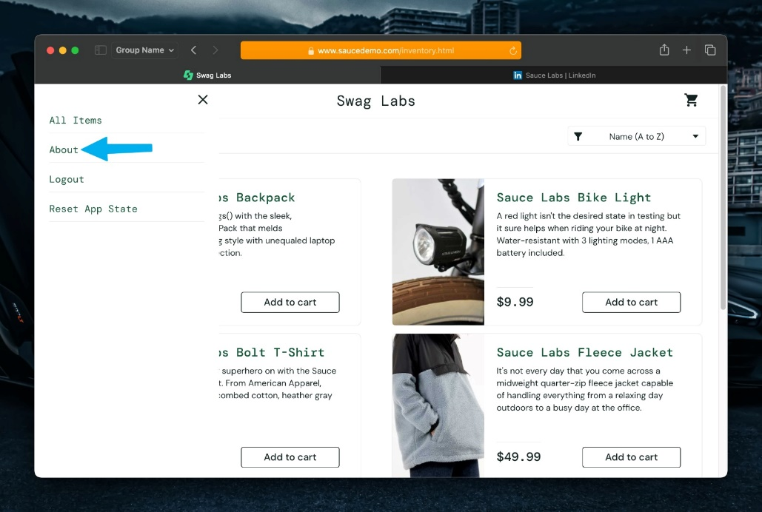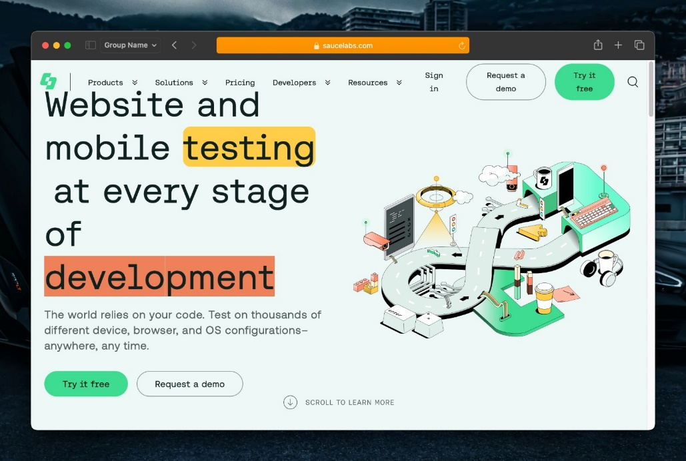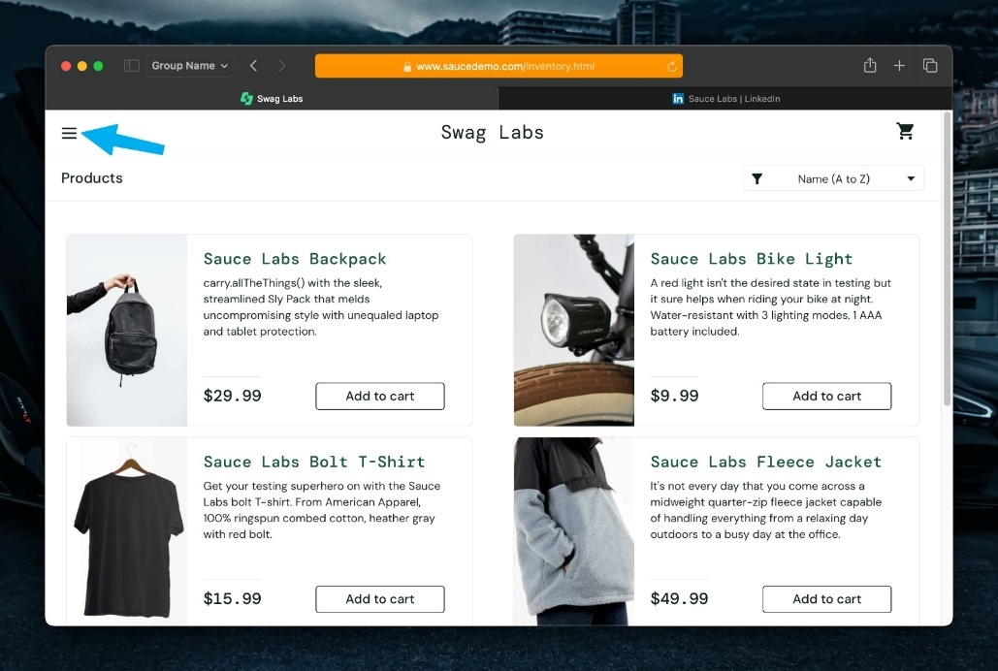

**Input:**

logoutUser();

static void logoutUser() {

        driver.findElement(By.id("react-burger-menu-btn")).click();

        delay(1);

        driver.findElement(By.id("logout_sidebar_link")).click();

        delay(1);

}

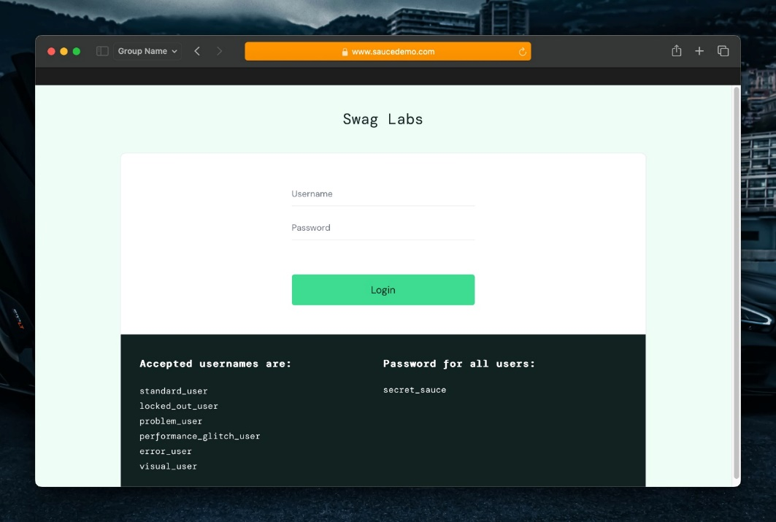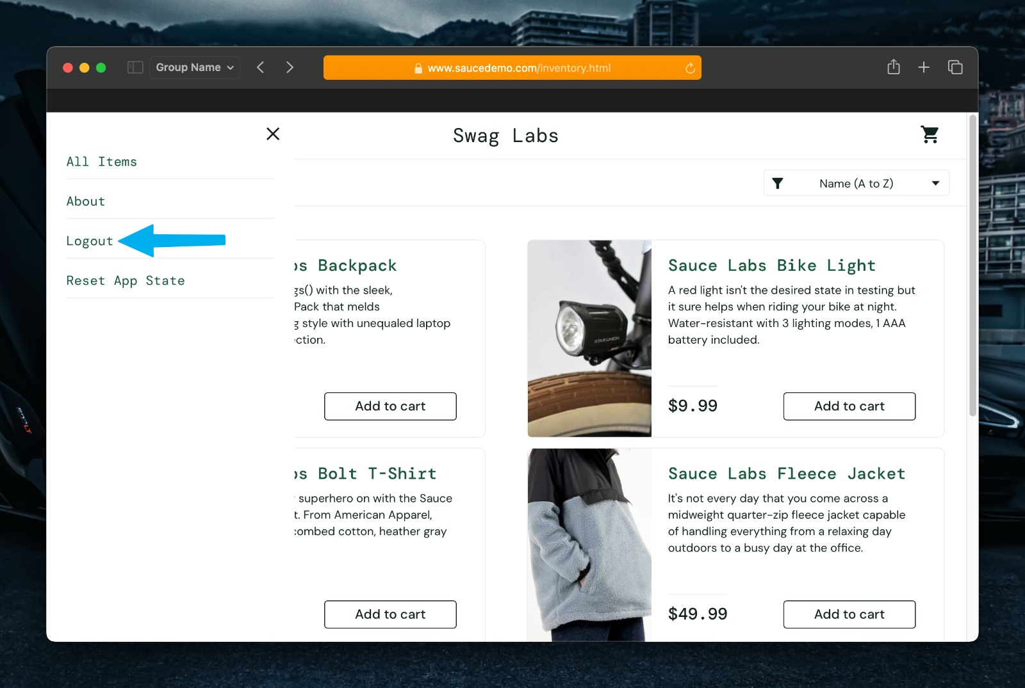**Output:**

**USER 2 – TEST CASES**

**Input:**

loginUser("locked_out_user");

static void loginUser(String username) {

        clear();

        driver.findElement(By.id("user-name")).sendKeys(username);

        driver.findElement(By.id("password")).sendKeys("secret_sauce");

        delay(1);

        driver.findElement(By.id("login-button")).click();

        delay(2);

}

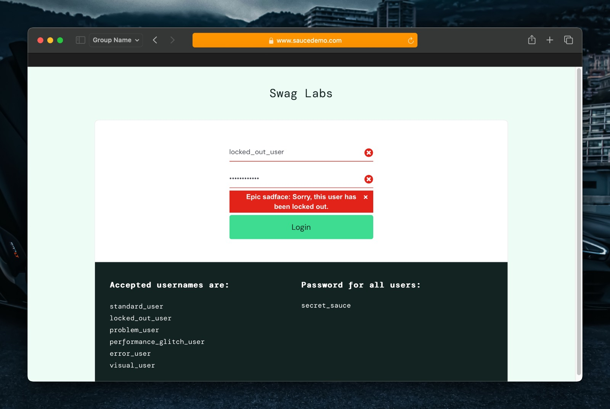**Output:**

**USER 3 – TEST CASES**

**Input:**

loginUser("problem_user");

static void loginUser(String username) {

        clear();

        driver.findElement(By.id("user-name")).sendKeys(username);

        driver.findElement(By.id("password")).sendKeys("secret_sauce");

        delay(1);

        driver.findElement(By.id("login-button")).click();

        delay(2);

}

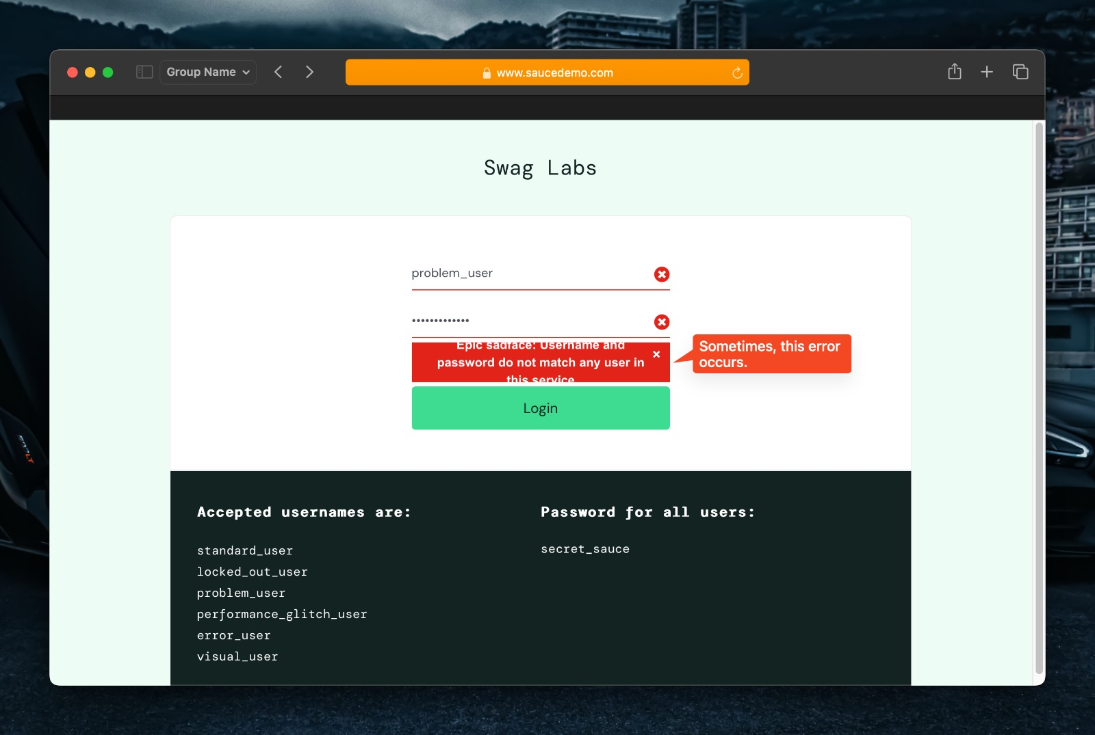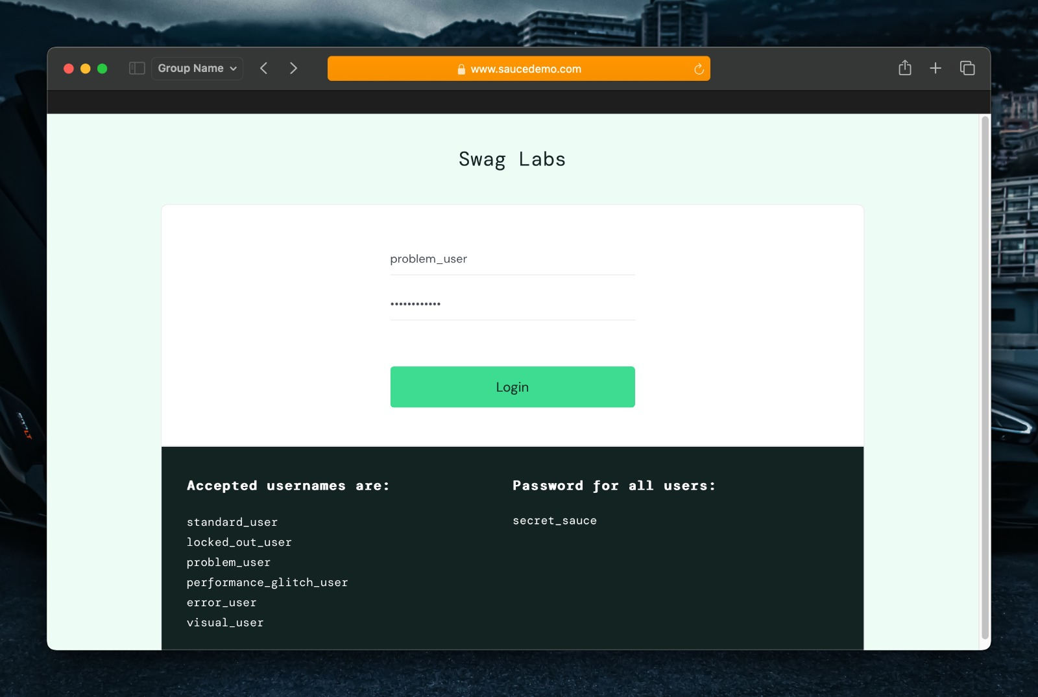**Output:**

**Input:**

userFunctions();

static void userFunctions() {

        productSortAndFilter();

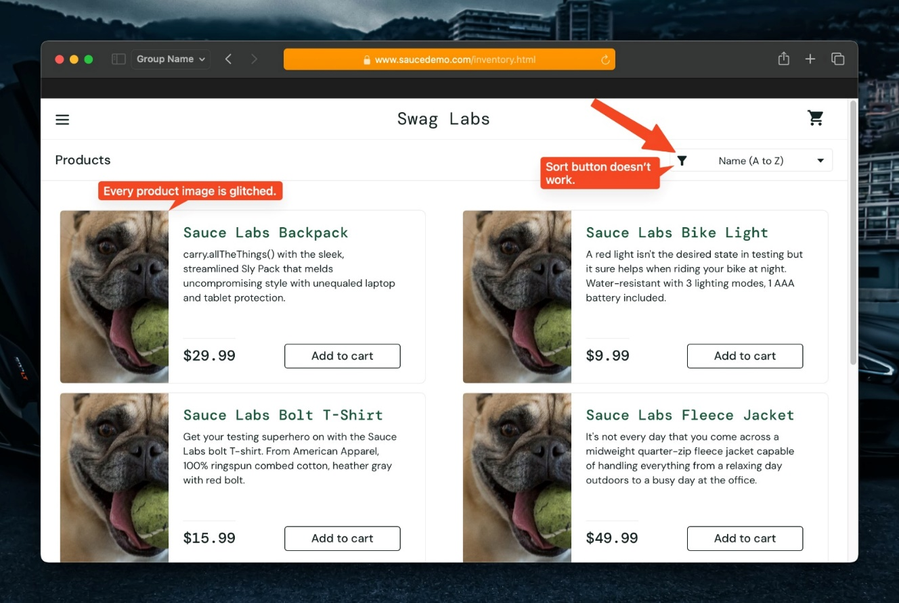

**Output:**

**Input:**

        addToCart();

**Output:**

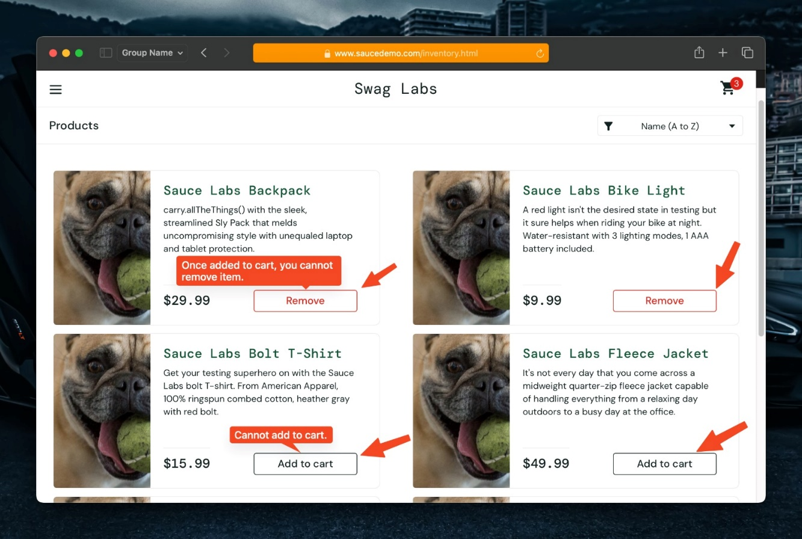

**Input:**

cartFunctions();

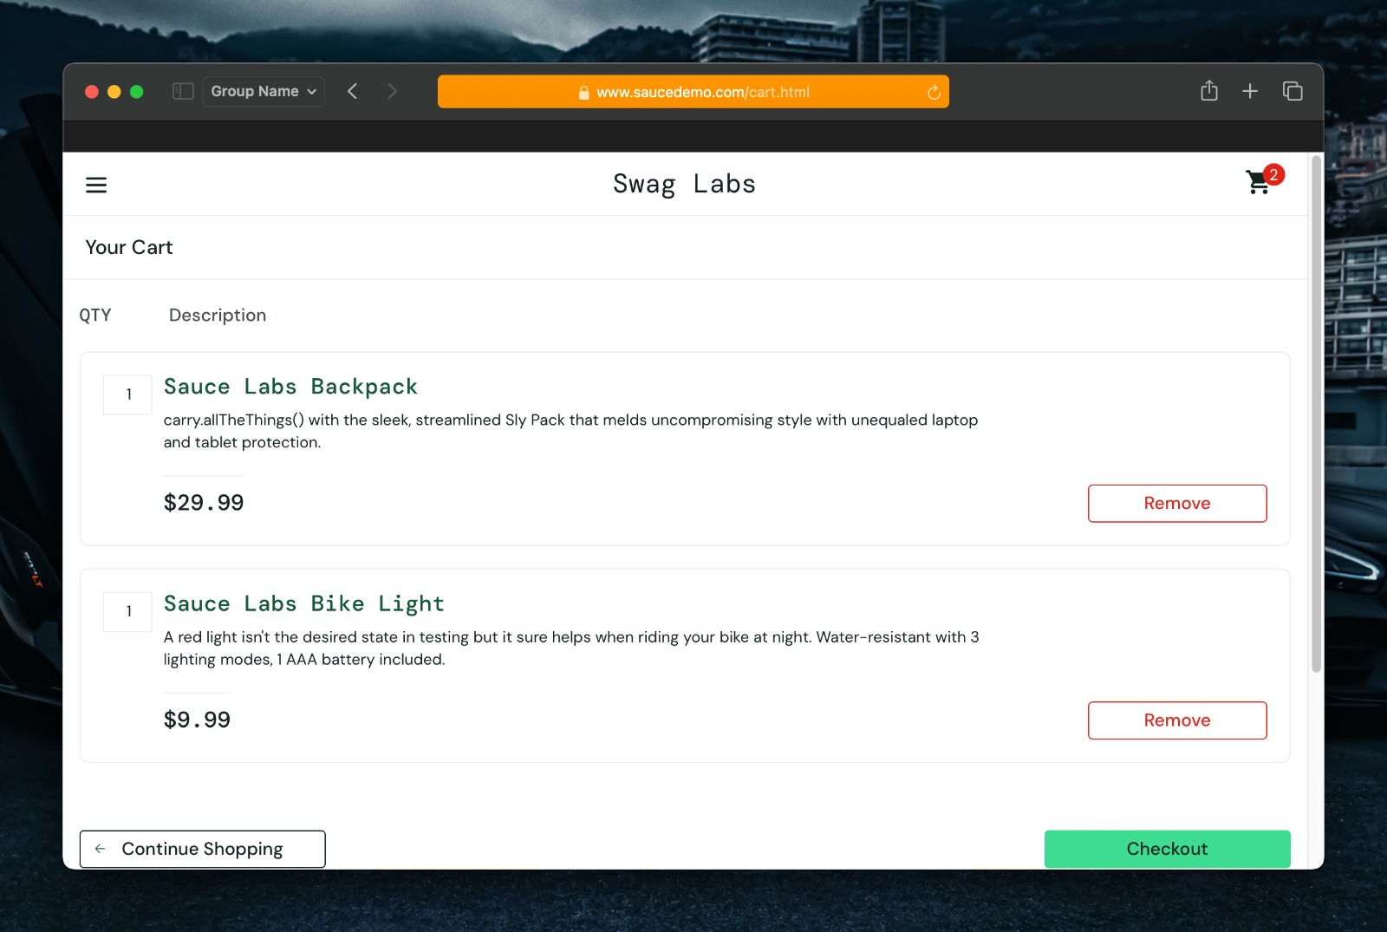**Output:**

**Input:**

checkoutFunctions();

    }

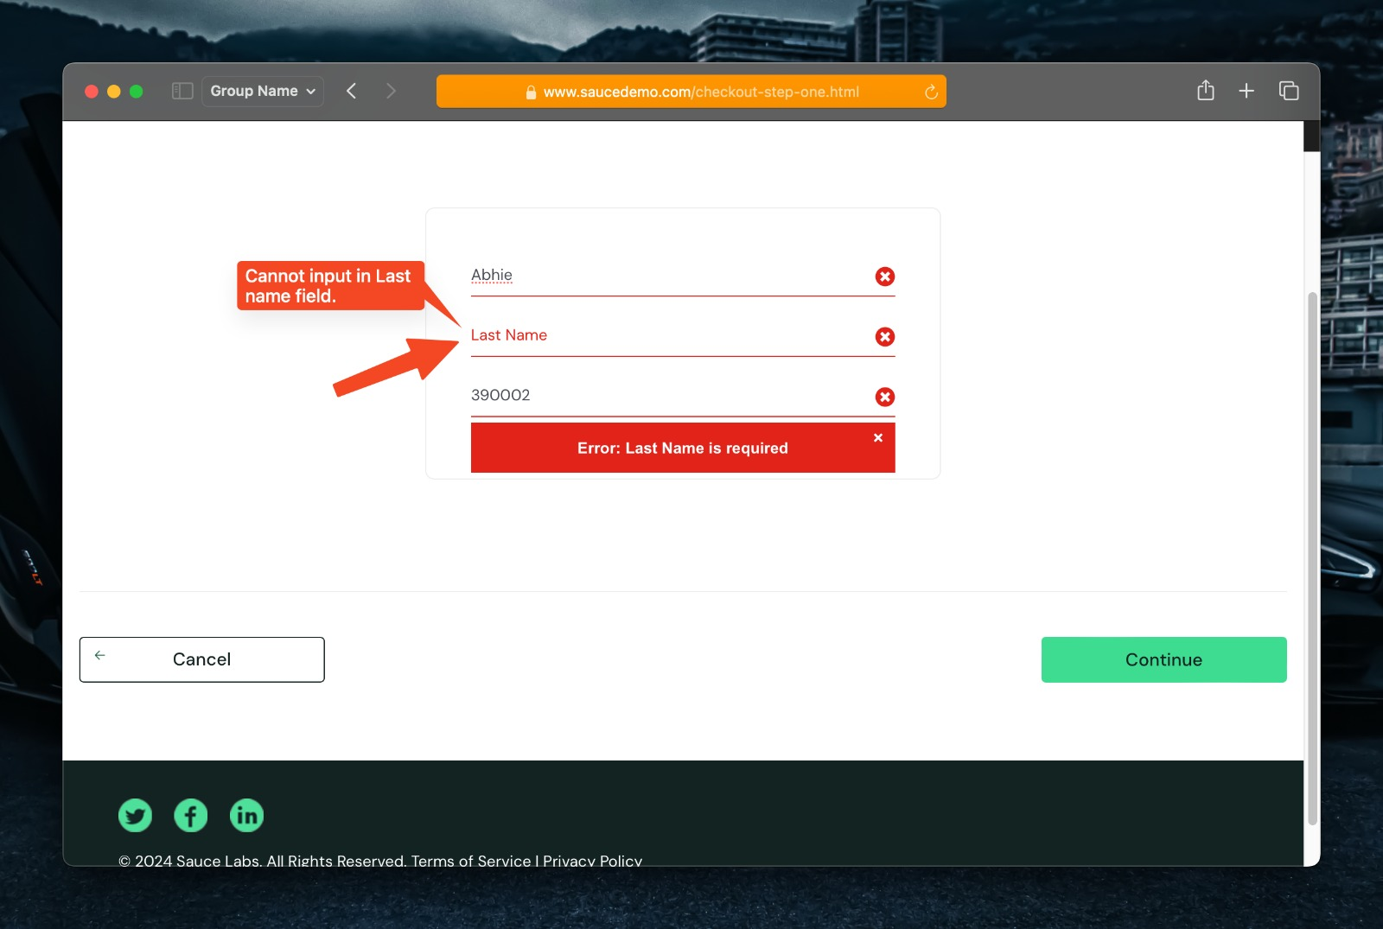**Output:**

**USER 4 – TEST CASES**

**Input:**

*//user 4*

        loginUser("performance_glitch_user");

        userFunctions();

static void userFunctions() {

        productSortAndFilter();

        addToCart();

        cartFunctions();

        checkoutFunctions();

    }

        logoutUser();

**Output:**

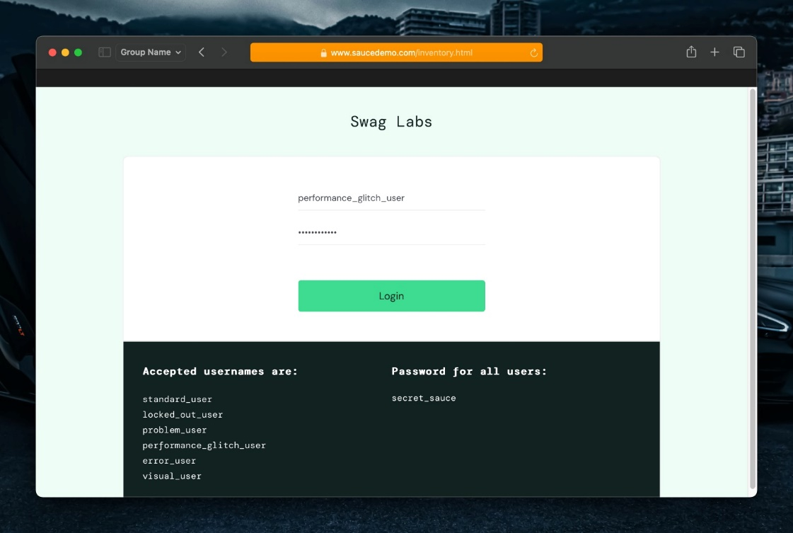

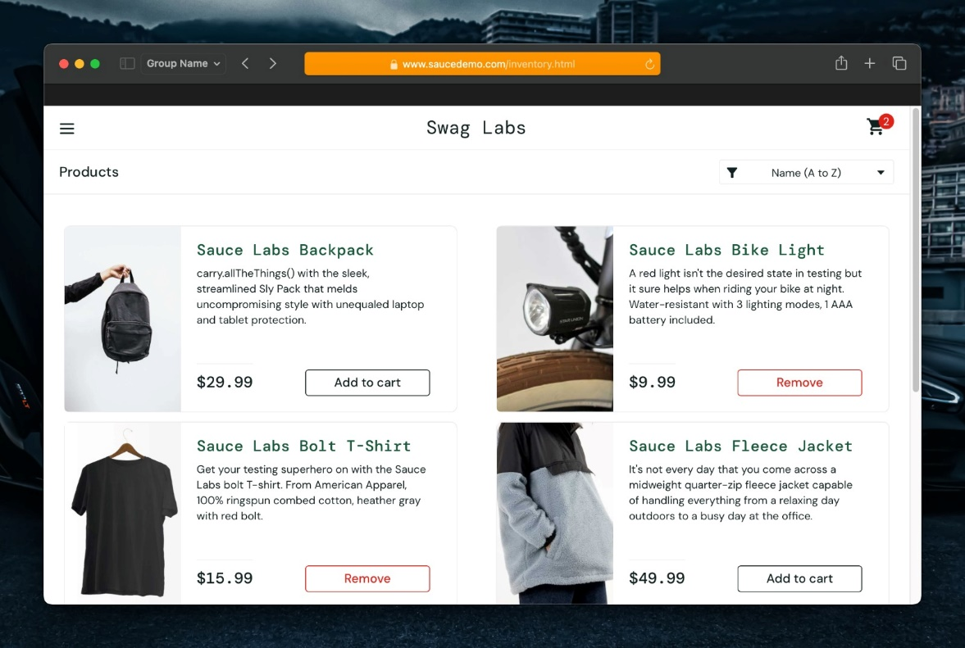

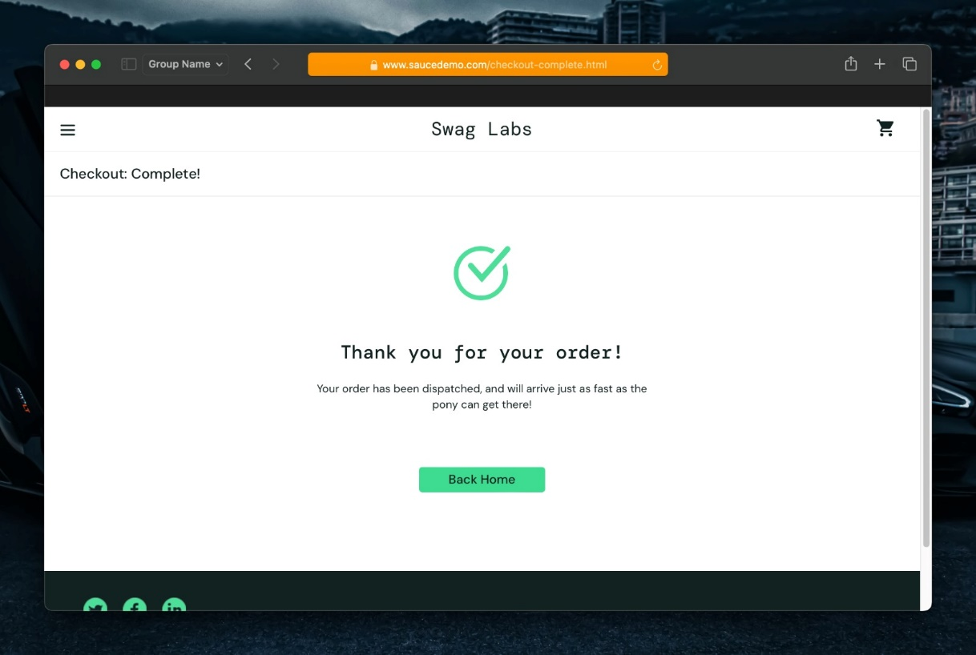

**USER 5 – TEST CASES**

**Input:**

*//user 5*

        loginUser("error_user");

        userFunctions();

static void userFunctions() {

        productSortAndFilter();

        addToCart();

        cartFunctions();

        checkoutFunctions();

    }

        logoutUser();

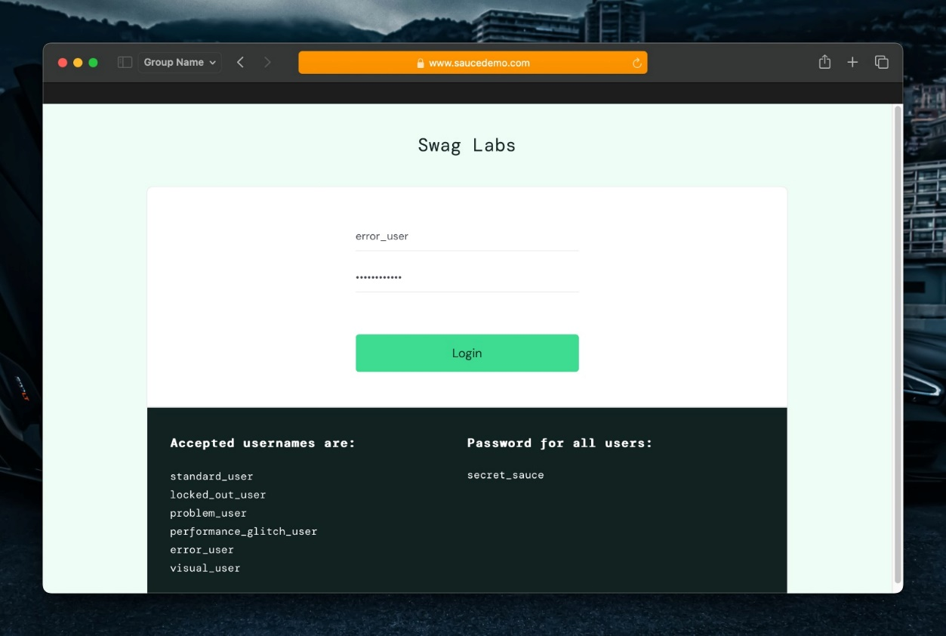**Output:**

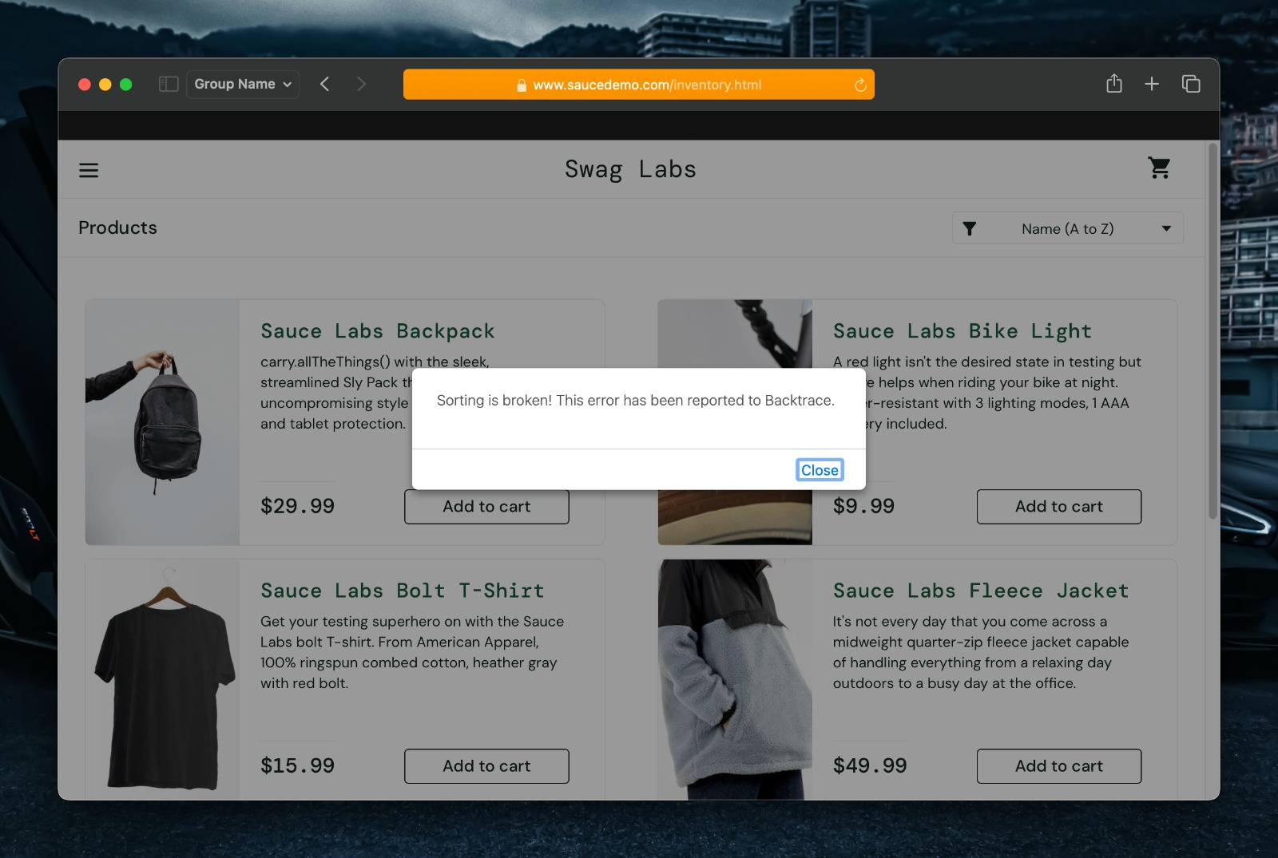

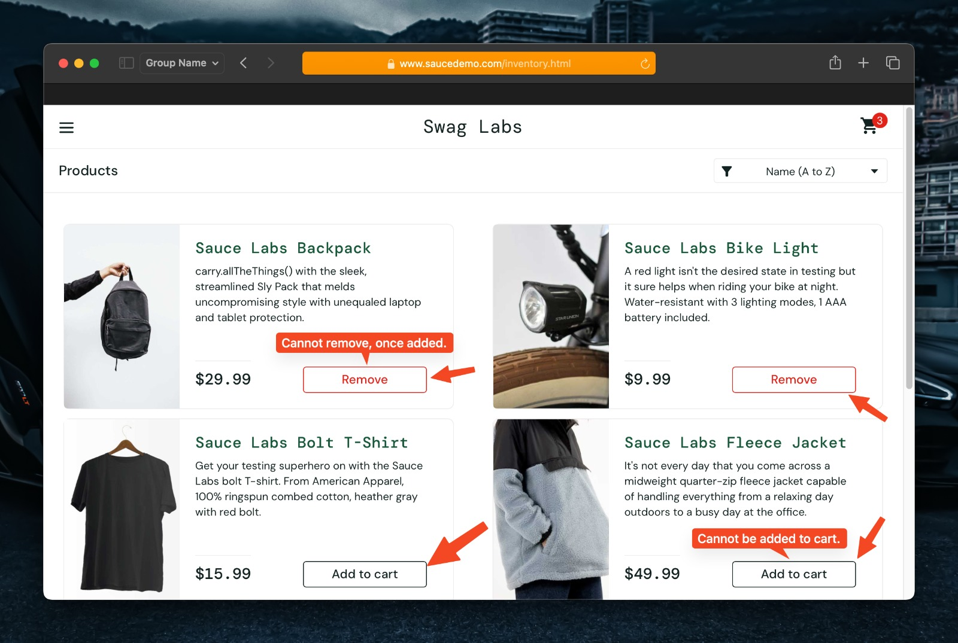

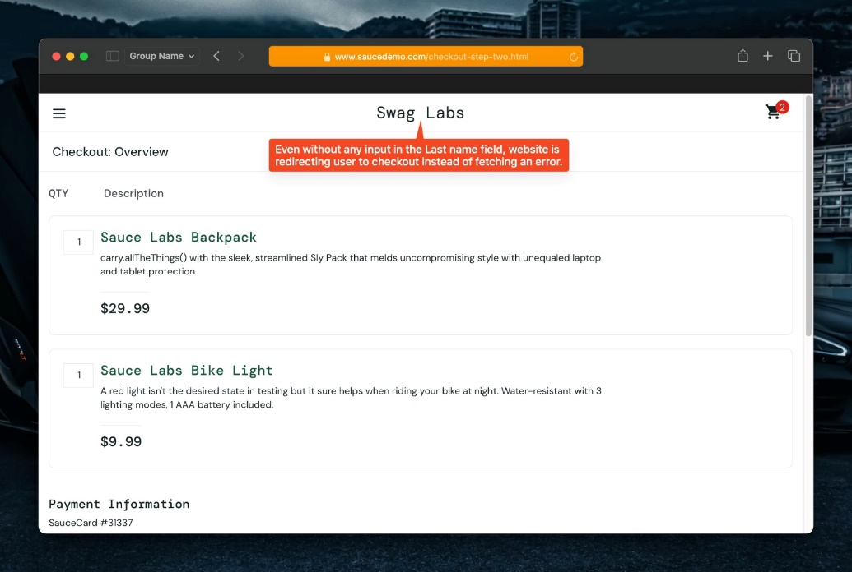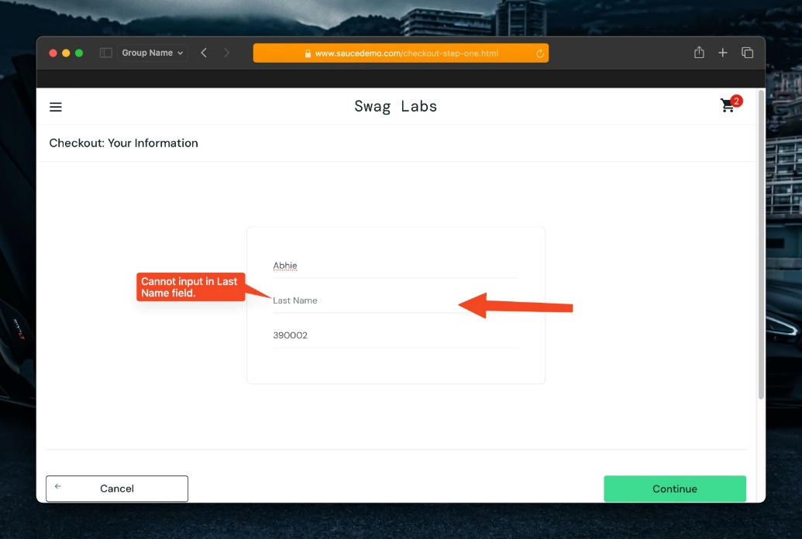

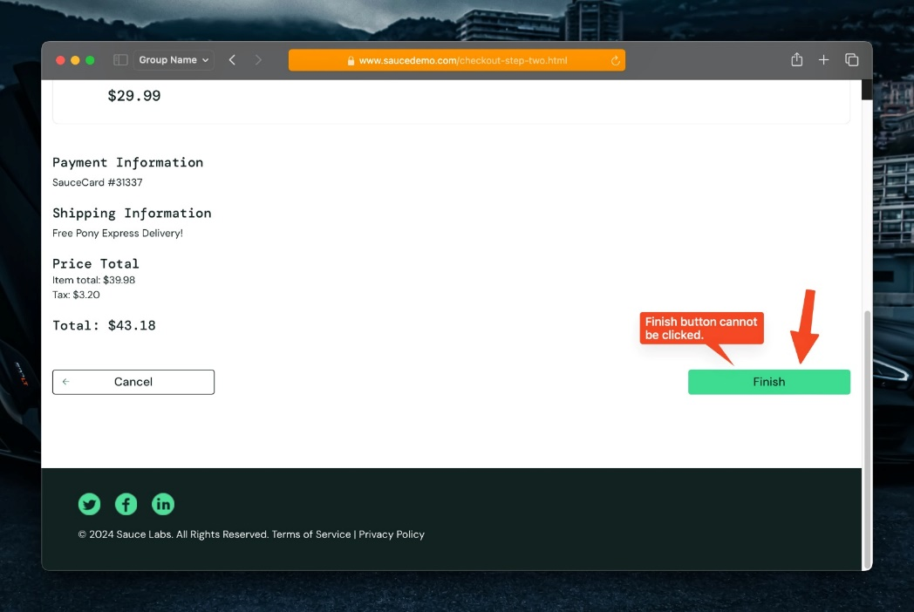

**USER 6 – TEST CASES**

**Input:**

*//user 6*

        loginUser("visual_user");

        userFunctions();

static void userFunctions() {

        productSortAndFilter();

        addToCart();

        cartFunctions();

        checkoutFunctions();

    }

        logoutUser();

**Output:**

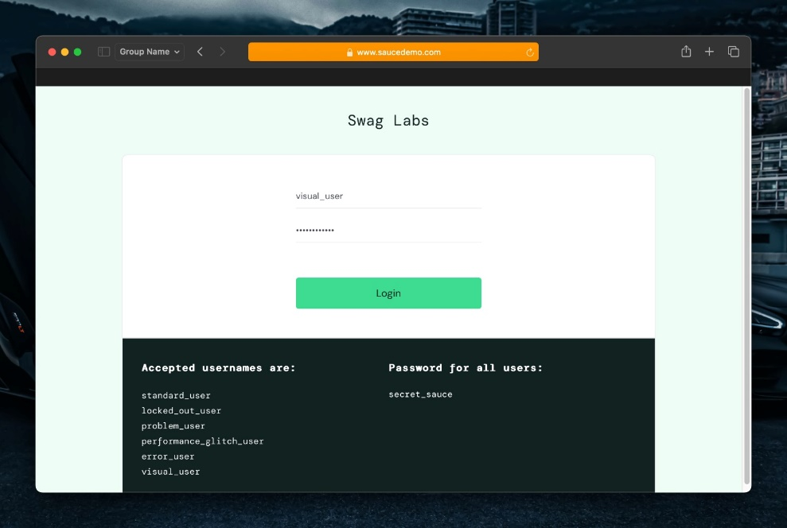

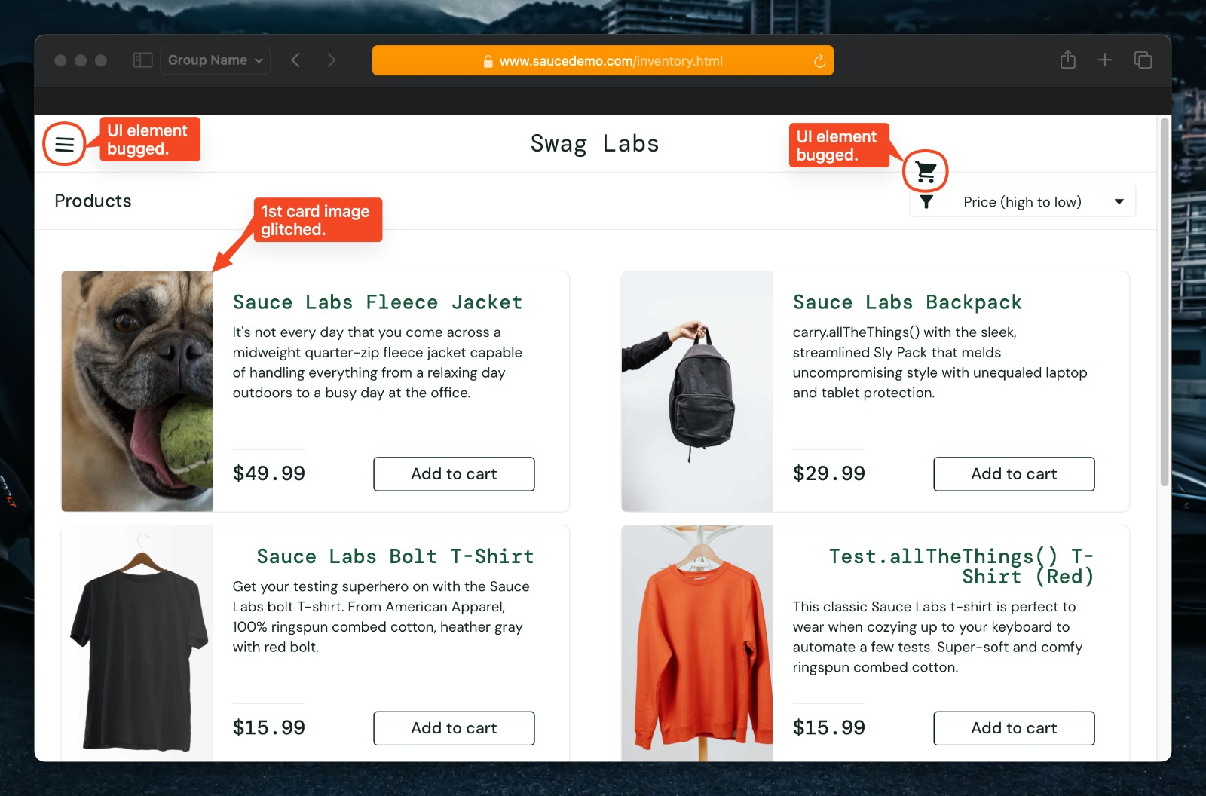

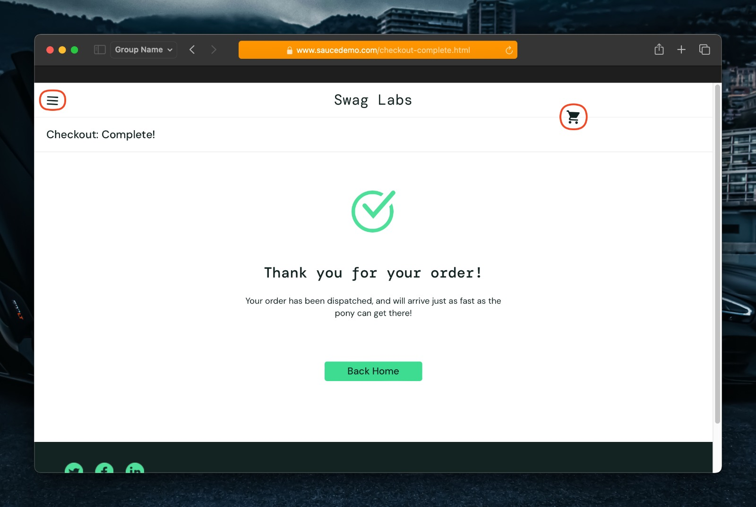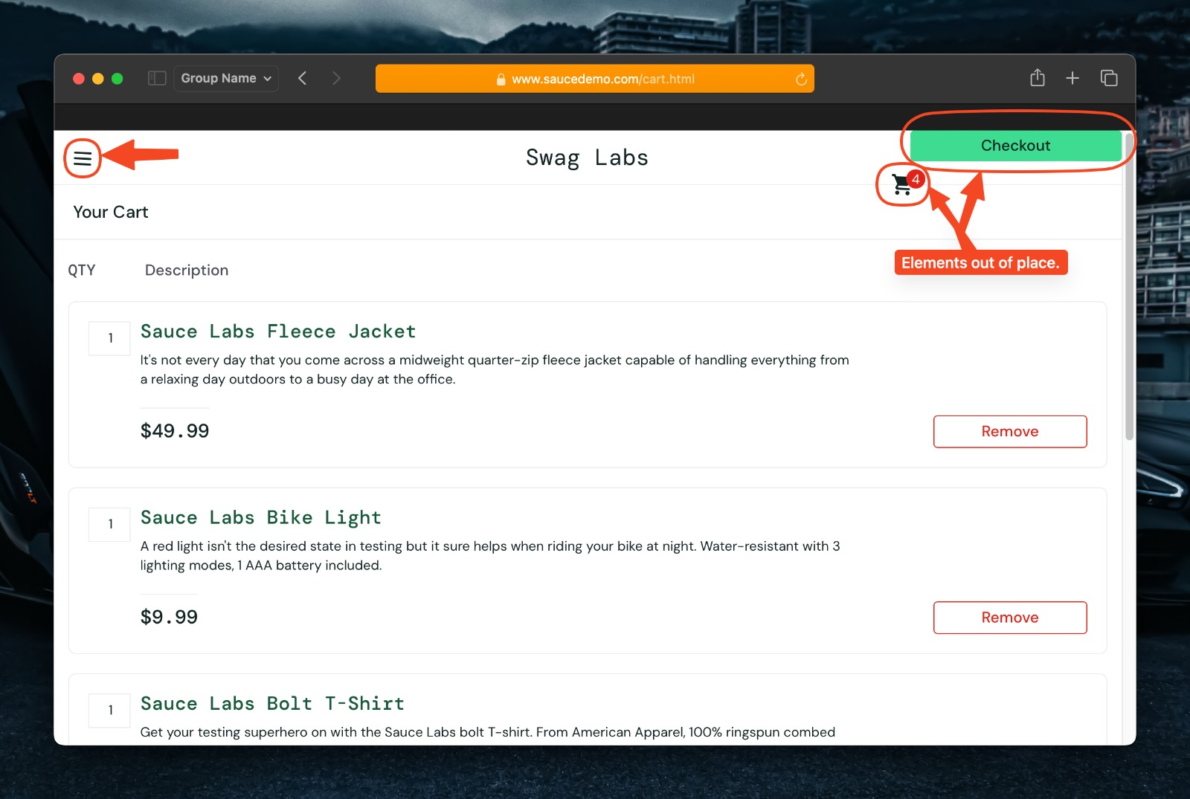

**Excel: Sheet 1 - Login**

|  |  |  |  |  |
| --- | --- | --- | --- | --- |
| **Pre Conditions** | | | | |
| **1** | Opened the link for test case : <https://www.saucedemo.com/> | | | |
| **Step No.** | **Test Step** | **Expected Result** | **Actual Result** | **Test Data** |
| **1** | Launch Safari browser | Safari browser should be launched | Safari browser launched successfully |  |
| **2** | Navigate to "[**www.saucedemo.com**](http://www.google.com/)" | SauceDemo login page should be loaded | SauceDemo login page displayed successfully |  |
| **3** | Enter **Username 1** in the login field | Username should be entered in the login field | Username entered successfully | Username1: "**standard_user**" |
| **4** | Enter **Password** in the login field | Password should be entered in the login field | Password enterd successfully | Password: "**secret_sauce**" |
| **5** | Click on Login button | If the username and password are correct, user should be logged in | User logged in succesfully |  |
| **6** | Verify if the user is being redirected to the home page | Product page should be displayed | Product page displayed successfully |  |
| **7** | Enter **Username 2** in the login field | Username should be entered in the login field | Username entered successfully | Username1: "**locked_out_user**" |
| **8** | Enter **Password** in the login field | Password should be entered in the login field | Password enterd successfully | Password: "**secret_sauce**" |
| **9** | Click on Login button | If the username and password are correct, user should be logged in and into t | User **couldn't log in** - Incorrect username |  |
| **10** | Enter **Username 3** in the login field | Username should be entered in the login field | Username entered successfully | Username1: "**problem_user**" |
| **11** | Enter **Password** in the login field | Password should be entered in the login field | Sometimes correct password would **fetch errors** | Password: "**secret_sauce**" |
| **12** | Click on Login button | If the username and password are correct, user should be logged in | User logged in succesfully |  |
| **13** | Verify if the user is being redirected to the home page | Product page should be displayed | Product page displayed successfully |  |
| **14** | Enter **Username 4** in the login field | Username should be entered in the login field | Username entered successfully | Username1: "**performance_glitch_user**" |
| **15** | Enter **Password** in the login field | Password should be entered in the login field | Password enterd successfully | Password: "**secret_sauce**" |
| **16** | Click on Login button | If the username and password are correct, user should be logged in | User logged in succesfully |  |
| **17** | Verify if the user is being redirected to the home page | Product page should be displayed | Product page displayed **slowly** with **high latency** |  |
| **18** | Enter **Username 5** in the login field | Username should be entered in the login field | Username entered successfully | Username1: "**error_user**" |
| **19** | Enter **Password** in the login field | Password should be entered in the login field | Password enterd successfully | Password: "**secret_sauce**" |
| **20** | Click on Login button | If the username and password are correct, user should be logged in | User logged in succesfully |  |
| **21** | Verify if the user is being redirected to the home page | Product page should be displayed | Product page displayed successfully |  |
| **22** | Enter **Username 6** in the login field | Username should be entered in the login field | Username entered successfully | Username1: "**visual_user**" |
| **23** | Enter **Password** in the login field | Password should be entered in the login field | Password enterd successfully | Password: "**secret_sauce**" |
| **24** | Click on Login button | If the username and password are correct, user should be logged in | User logged in succesfully |  |
| **25** | Verify if the user is being redirected to the home page | Product page should be displayed | Product page displayed successfully |  |
| **Post Conditions** | | | | |
| **1** | User is logged in and products page is displayed | | | |
| **2** | User logged out | | | |
| **3** | Browser is closed | | | |

**Sheet 2 - Product Sort and Filter**

|  |  |  |  |  |
| --- | --- | --- | --- | --- |
| **Pre Conditions** | | | | |
| **1** | Opened the link for test case : <https://www.saucedemo.com/> | | | |
| **Step No.** | **Test Step** | **Expected Result** | **Actual Result** | **Test Data** |
| **1** | Launch Safari browser | Safari browser should be launched | Safari browser launched successfully |  |
| **2** | Navigate to "[**www.saucedemo.com**](http://www.google.com/)" | SauceDemo login page should be loaded | SauceDemo login page displayed successfully |  |
| **3** | Login with **standard_user** credentials | User should be logged in successfully and redirected to products page | User logged in successfully and redirected to products page | "standard_user" and "secret_sauce" |
| **4** | Click on product sorting dropdown | Dropdown should expand to show sorting options | Dropdown expanded to show sorting options |  |
| **5** | Select all the available options one by one | Products should be sorted based on the option selected | Products sorted based on the option selected |  |
| **6** | Login with **locked_out_user** credentials | User should be logged in successfully and redirected to products page | User couldn't log in | "locked_out_user" and "secret_sauce" |
| **7** | Login with **problem_user** credentials | User should be logged in successfully and redirected to products page | User logged in successfully and redirected to products page | "problem_user" and "secret_sauce" |
| **8** | Click on product sorting dropdown | Dropdown should expand to show sorting options | Dropdown expanded to show sorting options |  |
| **9** | Select all the available options one by one | Products should be sorted based on the option selected | Products **aren't** being sorted |  |
| **10** | Login with **performance_glitch_user** credentials | User should be logged in successfully and redirected to products page | User logged in successfully and redirected to products page | "performance_glitch_user" and "secret_sauce" |
| **11** | Click on product sorting dropdown | Dropdown should expand to show sorting options | Dropdown expanded to show sorting options |  |
| **12** | Select all the available options one by one | Products should be sorted based on the option selected | Products sorted based on the option selected but very **slowly** |  |
| **13** | Login with **error_user** credentials | User should be logged in successfully and redirected to products page | User logged in successfully and redirected to products page | "error_user" and "secret_sauce" |
| **14** | Click on product sorting dropdown | Dropdown should expand to show sorting options | Dropdown expanded to show sorting options |  |
| **15** | Select all the available options one by one | Products should be sorted based on the option selected | **Sorting is broken**, shows error message |  |
| **16** | Login with **visual_user** credentials | User should be logged in successfully and redirected to products page | User logged in successfully and redirected to products page | "visual_user" and "secret_sauce" |
| **17** | Click on product sorting dropdown | Dropdown should expand to show sorting options | Dropdown expanded to show sorting options |  |
| **18** | Select all the available options one by one | Products should be sorted based on the option selected | Products sorted based on the option selected |  |
| **Post Conditions** | | | | |
| **1** | User logged out | | | |
| **2** | Browser is closed | | | |

**Sheet 3 - Add to Cart**

|  |  |  |  |  |
| --- | --- | --- | --- | --- |
| **Pre Conditions** | | | | |
| **1** | Opened the link for test case : <https://www.saucedemo.com/> | | | |
| **Step No.** | **Test Step** | **Expected Result** | **Actual Result** | **Test Data** |
| **1** | Launch Safari browser | Safari browser should be launched | Safari browser launched successfully |  |
| **2** | Navigate to "[**www.saucedemo.com**](http://www.google.com/)" | SauceDemo login page should be loaded | SauceDemo login page displayed successfully |  |
| **3** | Login with **standard_user** credentials | User should be logged in successfully and redirected to products page | User logged in successfully and redirected to products page | "standard_user" and "secret_sauce" |
| **4** | Click on "Add to Cart" for a product | Product should be added to the cart | Product added to the cart successfully |  |
| **5** | Click on "Remove" for a product | Product should be removed from the cart | Product removed from the cart successfully |  |
| **6** | Verify product is added to the cart | Product should be visible in the cart | Product is visible in the cart |  |
| **7** | Login with **locked_out_user** credentials | User should be logged in successfully and redirected to products page | User couldn't log in | "locked_out_user" and "secret_sauce" |
| **8** | Login with **problem_user** credentials | User should be logged in successfully and redirected to products page | User logged in successfully and redirected to products page | "problem_user" and "secret_sauce" |
| **9** | Click on "Add to Cart" for a product | Product should be added to the cart | Some products **couldn't be added** to cart |  |
| **10** | Click on "Remove" for a product | Product should be removed from the cart | Product **couldn't be removed** from the cart |  |
| **11** | Verify product is added to the cart | Product should be visible in the cart | Product visible in the cart |  |
| **12** | Login with **performance_glitch_user** credentials | User should be logged in successfully and redirected to products page | User logged in successfully and redirected to products page | "performance_glitch_user" and "secret_sauce" |
| **13** | Click on "Add to Cart" for a product | Product should be added to the cart | Some products **couldn't be added** to cart |  |
| **14** | Click on "Remove" for a product | Product should be removed from the cart | Product **couldn't be removed** from the cart |  |
| **15** | Verify product is added to the cart | Product should be visible in the cart | Product is visible in the cart |  |
| **16** | Login with **error_user** credentials | User should be logged in successfully and redirected to products page | User logged in successfully and redirected to products page | "error_user" and "secret_sauce" |
| **17** | Click on "Add to Cart" for a product | Product should be added to the cart | Some products **couldn't be added** to cart |  |
| **18** | Click on "Remove" for a product | Product should be removed from the cart | Product **couldn't be removed** from the cart |  |
| **19** | Verify product is added to the cart | Product should be visible in the cart | Product is visible in the cart |  |
| **20** | Login with **visual_user** credentials | User should be logged in successfully and redirected to products page | User logged in successfully and redirected to products page | "visual_user" and "secret_sauce" |
| **21** | Click on "Add to Cart" for a product | Product should be added to the cart | Product added to the cart successfully |  |
| **22** | Click on "Remove" for a product | Product should be removed from the cart | Product removed from the cart successfully |  |
| **23** | Verify product is added to the cart | Product should be visible in the cart | Product is visible in the cart |  |
| **Post Conditions** | | | | |
| **1** | User visits the cart | | | |
| **2** | User logged out | | | |
| **3** | Browser is closed | | | |

**Sheet 4 - Cart**

|  |  |  |  |  |
| --- | --- | --- | --- | --- |
| **Pre Conditions** | | | | |
| **1** | Opened the link for test case : <https://www.saucedemo.com/> | | | |
| **Step No.** | **Test Step** | **Expected Result** | **Actual Result** | **Test Data** |
| **1** | Launch Safari browser | Safari browser should be launched | Safari browser launched successfully |  |
| **2** | Navigate to "[**www.saucedemo.com**](http://www.google.com/)" | SauceDemo login page should be loaded | SauceDemo login page displayed successfully |  |
| **3** | Login with **standard_user** credentials | User should be logged in successfully and redirected to products page | User logged in successfully and redirected to products page | "standard_user" and "secret_sauce" |
| **4** | Click on cart icon to view cart | Cart page should be displayed | Cart page displayed successfully |  |
| **5** | Remove a product from the cart | Product should be removed from the cart | Product removed from the cart successfully |  |
| **6** | Login with **locked_out_user** credentials | User should be logged in successfully and redirected to products page | User couldn't log in | "locked_out_user" and "secret_sauce" |
| **7** | Login with **problem_user** credentials | User should be logged in successfully and redirected to products page | User logged in successfully and redirected to products page | "problem_user" and "secret_sauce" |
| **8** | Click on cart icon to view cart | Cart page should be displayed | Cart page displayed successfully |  |
| **9** | Remove a product from the cart | Product should be removed from the cart | Product removed from the cart successfully |  |
| **10** | Login with **performance_glitch_user** credentials | User should be logged in successfully and redirected to products page | User logged in successfully and redirected to products page | "performance_glitch_user" and "secret_sauce" |
| **11** | Click on cart icon to view cart | Cart page should be displayed | Cart page displayed successfully |  |
| **12** | Remove a product from the cart | Product should be removed from the cart | Product removed from the cart successfully |  |
| **13** | Login with **error_user** credentials | User should be logged in successfully and redirected to products page | User logged in successfully and redirected to products page | "error_user" and "secret_sauce" |
| **14** | Click on cart icon to view cart | Cart page should be displayed | Cart page displayed successfully |  |
| **15** | Remove a product from the cart | Product should be removed from the cart | Product removed from the cart successfully |  |
| **16** | Login with **visual_user** credentials | User should be logged in successfully and redirected to products page | User logged in successfully and redirected to products page | "visual_user" and "secret_sauce" |
| **17** | Click on cart icon to view cart | Cart page should be displayed | Cart page displayed successfully |  |
| **18** | Remove a product from the cart | Product should be removed from the cart | Product removed from the cart successfully |  |
| **Post Conditions** | | | | |
| **1** | User is redirected to the chekout page | | | |
| **2** | User logged out | | | |
| **3** | Browser is closed | | | |

**Sheet 5 - Checkout**

|  |  |  |  |  |
| --- | --- | --- | --- | --- |
| **Pre Conditions** | | | | |
| **1** | Opened the link for test case 1 : <https://www.saucedemo.com/> | | | |
| **Step No.** | **Test Step** | **Expected Result** | **Actual Result** | **Test Data** |
| **1** | Launch Safari browser | Safari browser should be launched | Safari browser launched successfully |  |
| **2** | Navigate to "[**www.saucedemo.com**](http://www.google.com/)" | SauceDemo login page should be loaded | SauceDemo login page displayed successfully |  |
| **3** | Login with **standard_user** credentials | User should be logged in successfully and redirected to products page | User logged in successfully and redirected to products page | "standard_user" and "secret_sauce" |
| **4** | Fill out checkout information | Information fields should be filled out | Information fields could be filled out successfully | Name, Last Name and Postal code |
| **5** | Click on "Continue" button | User should proceed to the next step of checkout only if they fill out checkout information | User proceeded to the next step of checkout successfully |  |
| **6** | Click on "Finish" button | Order should be placed successfully | Order placed successfully |  |
| **7** | Login with **locked_out_user** credentials | User should be logged in successfully and redirected to products page | User couldn't log in | "locked_out_user" and "secret_sauce" |
| **8** | Login with **problem_user** credentials | User should be logged in successfully and redirected to products page | User logged in successfully and redirected to products page | "problem_user" and "secret_sauce" |
| **9** | Fill out checkout information | Information fields should be filled out | **Unable to input text into the last name field** | Name, Last Name and Postal code |
| **10** | Click on "Continue" button | User should proceed to the next step of checkout only if they fill out checkout information | **Unable to proceed due to no input in the last name field** |  |
| **11** | Click on "Finish" button | Order should be placed successfully | Order placed successfully |  |
| **12** | Login with **performance_glitch_user** credentials | User should be logged in successfully and redirected to products page | User logged in successfully and redirected to products page | "performance_glitch_user" and "secret_sauce" |
| **13** | Fill out checkout information | Information fields should be filled out | Information fields could be filled out successfully | Name, Last Name and Postal code |
| **14** | Click on "Continue" button | User should proceed to the next step of checkout only if they fill out checkout information | User proceeded to the next step of checkout successfully |  |
| **15** | Click on "Finish" button | Order should be placed successfully | Order placed successfully |  |
| **16** | Login with **error_user** credentials | User should be logged in successfully and redirected to products page | User logged in successfully and redirected to products page | "error_user" and "secret_sauce" |
| **17** | Fill out checkout information | Information fields should be filled out | **Unable to input text into the last name field** | Name, Last Name and Postal code |
| **18** | Click on "Continue" button | User should proceed to the next step of checkout only if they fill out checkout information | **User proceeded to the next step of checkout successfully** |  |
| **19** | Click on "Finish" button | Order should be placed successfully | **Unable to complete the checkout process due to non-functioning finish button** |  |
| **20** | Login with **visual_user** credentials | User should be logged in successfully and redirected to products page | User logged in successfully and redirected to products page | "visual_user" and "secret_sauce" |
| **21** | Fill out checkout information | Information fields should be filled out | Information fields could be filled out successfully | Name, Last Name and Postal code |
| **22** | Click on "Continue" button | User should proceed to the next step of checkout only if they fill out checkout information | User proceeded to the next step of checkout successfully |  |
| **23** | Click on "Finish" button | Order should be placed successfully | Order placed successfully |  |
| **Post Conditions** | | | | |
| **1** | User is redirected to the products page | | | |
| **2** | User logged out | | | |
| **3** | Browser is closed | | | |

**Sheet 6 - Navigation and External Links**

|  |  |  |  |  |
| --- | --- | --- | --- | --- |
| **Pre Conditions** | | | | |
| **1** | Opened the link for test case 1 : <https://www.saucedemo.com/> | | | |
| **Step No.** | **Test Step** | **Expected Result** | **Actual Result** | **Test Data** |
| **1** | Launch Safari browser | Safari browser should be launched | Safari browser launched successfully |  |
| **2** | Navigate to "[**www.saucedemo.com**](http://www.google.com/)" | SauceDemo login page should be loaded | SauceDemo login page displayed successfully |  |
| **3** | Click on Social media buttons | User should be redirected to the respective social media links | User redirected to the respective social media links | Twitter, Facebook and LinkedIn buttons |
| **4** | Click on burger menu icon | Menu options should be displayed | Menu options displayed |  |
| **5** | Click on "About" option | User should be redirected to the about page | User redirected to the about page |  |
| **6** | Click on "Logout" option | User should be logged out | User logged out |  |
| **Post Conditions** | | | | |
| **1** | User logged out | | | |
| **2** | Browser is closed | | | |

**Sheet 7 – UI**

|  |  |  |  |  |
| --- | --- | --- | --- | --- |
| **Pre Conditions** | | | | |
| **1** | Opened the link for test case 1 : <https://www.saucedemo.com/> | | | |
| **Step No.** | **Test Step** | **Expected Result** | **Actual Result** | **Test Data** |
| **1** | Launch Safari browser | Safari browser should be launched | Safari browser launched successfully |  |
| **2** | Navigate to "[**www.saucedemo.com**](http://www.google.com/)" | SauceDemo login page should be loaded | SauceDemo login page displayed successfully |  |
| **3** | Verify login page UI elements | All UI elements (username field, password field, login button) should be present and aligned properly | All UI elements are presenf and aligned properly |  |
| **4** | Verify product listing page UI elements | All product images, names, prices, and add to cart buttons should be displayed and aligned properly | All product images, names, prices, and add to cart buttons are displayed and aligned properly except for **user 3** and **user 6** |  |
| **User 3:** All product card images are glitched |  |
| **User 6:** First product card image is glitched and cart and burger icons are misplaced. |  |
| **5** | Verify cart page UI elements | Cart items, prices, quantities, and checkout button should be displayed and aligned properly | Cart items, prices and quantities are displayed and aligned properly but **checkout button** is misplaced for **user 6** |  |
| **6** | Verify checkout page UI elements | Checkout form fields, summary, and place order button should be displayed and aligned properly | Checkout form fields, summary, and place order button are displayed and aligned properly |  |
| **7** | Verify navigation menu UI elements | Burger menu icon, menu options (logout, about) should be displayed and aligned properly | Burger menu icon, menu options (logout, about) are displayed and aligned properly |  |
| **8** | Verify oberall website performance | The website should run smoothly without any lags or disturbances | **User 4:** Website was laggy and many things were undoable |  |
| **Post Conditions** | | | | |
| **1** | User logged out | | | |
| **2** | Browser is closed | | | |

**Source Code:**

package Lab4;

import java.util.concurrent.TimeUnit;

import org.openqa.selenium.By;

import org.openqa.selenium.safari.SafariDriver;

public class Lab4_1 {

    static SafariDriver driver = new SafariDriver();

    public static void main(String[] args) {

        driver.get("https://www.saucedemo.com/");

*//user 1*

        loginUser("standard_user");

        userFunctions();

        logoutUser();

*//user 2*

        loginUser("locked_out_user");

        clear();

*//user 3*

        loginUser("problem_user");

        userFunctions();

        logoutUser();

*//user 4*

        loginUser("performance_glitch_user");

        userFunctions();

        logoutUser();

*//user 5*

        loginUser("error_user");

        userFunctions();

        logoutUser();

*//user 6*

        loginUser("visual_user");

        userFunctions();

        logoutUser();

        driver.quit();

    }

    static void loginUser(String username) {

        clear();

        driver.findElement(By.id("user-name")).sendKeys(username);

        driver.findElement(By.id("password")).sendKeys("secret_sauce");

        delay(1);

        driver.findElement(By.id("login-button")).click();

        delay(2);

    }

    static void logoutUser() {

        driver.findElement(By.id("react-burger-menu-btn")).click();

        delay(1);

        driver.findElement(By.id("logout_sidebar_link")).click();

        delay(1);

    }

    static void userFunctions() {

        productSortAndFilter();

        addToCart();

        cartFunctions();

        checkoutFunctions();

    }

*//Product Sort and Filter*

    static void productSortAndFilter() {

        delay(2);

*//trying to click the sort button using various classnames*

        try {

            driver.findElement(By.className("product_sort_container")).click();

        } catch (Exception e) {

            try {

                driver.findElement(By.className("select_container")).click();

                driver.findElement(By.xpath("//*[@id=\"header_container\"]/div[2]/div/span/select")).click();

            } catch (Exception ex) {

                System.out.println("Unable to find the element");

            }

        }

*//sort products by Name (Z to A)*

        driver.findElement(By.xpath("//*[@id=\"header_container\"]/div[2]/div/span/select/option[2]")).click();

        delay(1);

*//sort products by price (low to high)*

        driver.findElement(By.xpath("//*[@id=\"header_container\"]/div[2]/div/span/select/option[3]")).click();

        delay(1);

*//sort products by price (high to low)*

        driver.findElement(By.xpath("//*[@id=\"header_container\"]/div[2]/div/span/select/option[4]")).click();

        delay(1);

    }

*// Product Add to Cart*

    static void addToCart() {

*//add and remove "Sauce Labs Backpack" to cart*

        driver.findElement(By.id("add-to-cart-sauce-labs-backpack")).click();

        delay(1);

        driver.findElement(By.id("remove-sauce-labs-backpack")).click();

        delay(1);

*//add products to cart*

        driver.findElement(By.id("add-to-cart-sauce-labs-bike-light")).click();

        delay(1);

        driver.findElement(By.id("add-to-cart-sauce-labs-onesie")).click();

        delay(1);

        driver.findElement(By.id("add-to-cart-sauce-labs-bolt-t-shirt")).click();

        delay(1);

        driver.findElement(By.id("add-to-cart-test.allthethings()-t-shirt-(red)")).click();

        delay(1);

        driver.findElement(By.id("add-to-cart-sauce-labs-fleece-jacket")).click();

    }

*// Cart Functions*

    static void cartFunctions() {

*//navigate to cart*

        driver.findElement(By.id("shopping_cart_container")).click();

        delay(1);

*//remove "Sauce Labs Onesie" from cart*

        driver.findElement(By.id("remove-sauce-labs-onesie")).click();

*//checkout*

        driver.findElement(By.id("checkout")).click();

    }

*// Checkout Functions*

    static void checkoutFunctions() {

*// Checkout Functions*

*//fill out checkout information*

        try {

            driver.findElement(By.id("first-name")).sendKeys("Abhie");

            driver.findElement(By.id("last-name")).sendKeys("Mon2");

            driver.findElement(By.id("postal-code")).sendKeys("390002");

*//continue to overview*

            driver.findElement(By.id("continue")).click();

*//finish checkout*

            delay(1);

            driver.findElement(By.id("finish")).click();

            delay(1);

*//back to products*

            driver.findElement(By.id("back-to-products")).click();

*//if last name couldn't be entered, cancel checkout*

        } catch (Exception e) {

            driver.findElement(By.id("cancel")).click();

        }

    }

*// Navigation and External Links*

    static void links() {

*//navigate to social media links*

         driver.findElement(By.xpath("//*[@id=\"page_wrapper\"]/footer/ul/li[1]/a")).click(); *//twitter*

         driver.findElement(By.xpath("//*[@id=\"page_wrapper\"]/footer/ul/li[2]/a")).click(); *//facebook*

         driver.findElement(By.xpath("//*[@id=\"page_wrapper\"]/footer/ul/li[3]/a")).click(); *//linkedin*

*//click on the burger menu*

        driver.findElement(By.id("react-burger-menu-btn")).click();

        delay(1);

*//about us*

        driver.findElement(By.id("about_sidebar_link")).click();

    }

*// Delay Function*

    public static void delay(int sec) {

        try {

            TimeUnit.SECONDS.sleep(sec);

        } catch (InterruptedException ie) {

            System.out.println("Error");

        }

    }

*// Clear Function*

    public static void clear() {

        driver.findElement(By.id("user-name")).clear();

        delay(1);

        driver.findElement(By.id("password")).clear();

        delay(1);

    }

}